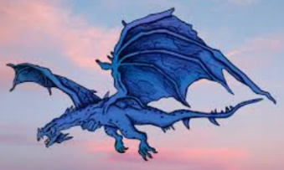
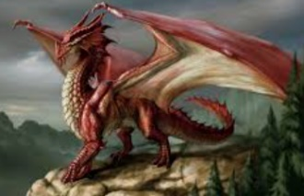
Dragon’s Power
The dragon’s bulging head is bigger than a bus,
The dragon’s scarlet eyes glow like fiery headlamps,
The dragon’s silver scales are tougher than diamonds,
The dragon’s cruel claws curve like crescent moons,
The dragon’s mighty jaws crunch bones like candy,
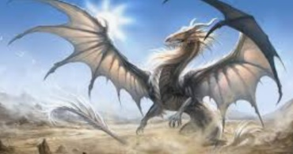
The dragon’s jagged tail can knock blocks of flats with one single swipe…

