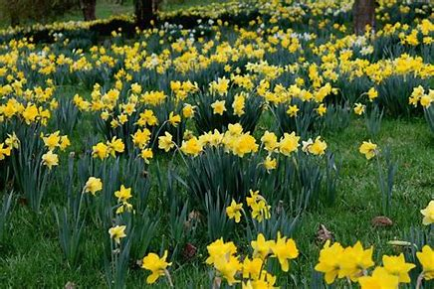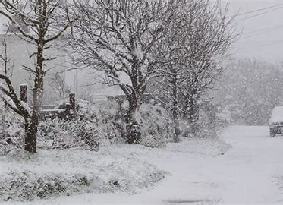**Foundation Spring Second Half Curriculum Overview**

**Communication & Language**

To use new vocabulary in different contexts. To engage in non-fiction books.

**Themes**

Winter

Spring

Easter

**Personal, Social and Emotional Development**

To consider the feelings and needs of others. To listen to the ideas of other children.

**Kea Values**

**Ready**

We have good manners

**Respectful**

We are kind

**Safe**

We follow instructions

**Literacy**

A sentence

Phonic scheme – Read Write Inc to consolidate work on Set 1 and Set 2 sounds.

**Physical Development**

To create short sequences. To balance and safely use apparatus.

**Key Texts**

Runaway Pancake

Three Little Pigs

Billy Goats Gruff

Chicken Licken

Bible Story – Easter

**Maths**

Numbers to 10 (9 and 10 focus), 1 more and 1 less of numbers to 10, combining groups, take away. To know 9 and 10 o’clock, recognise 10p, 3D shapes.

**Understanding the world**

My life story, people who help us in the community, Easter, Spring, gardening and growth.

**Expressive Arts and Design**

Art: Natural art, joining materials, cooking techniques.

Songs, rhymes, dynamics, genres of music