Foundation Autumn Second Curriculum Overview
Foundation Autumn Second Curriculum Overview
Themes
Celebrations
Bonfire Night
Diwali
Christmas
Communication & Language
Developing listening, attention and understanding
Speaking

Personal, Social and Emotional Development
Developing relationships
Sharing and using resources

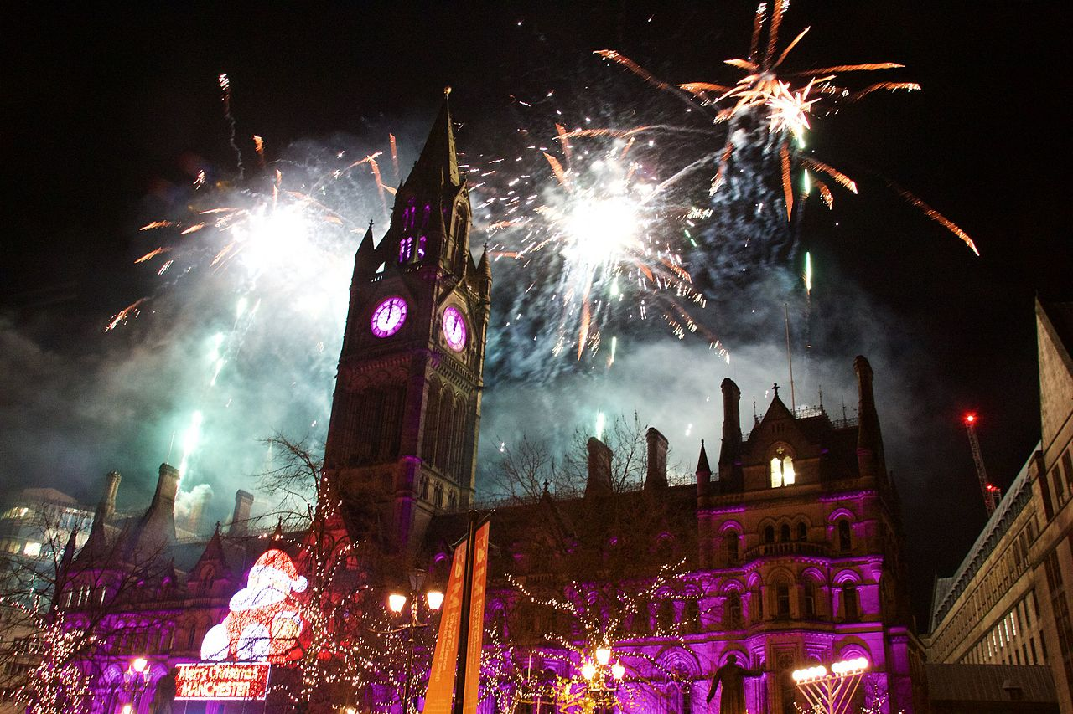
Kea Values
Ready
We have good manners

Respectful
We are kind
Safe
We follow instructions

Expressive Arts and Design
Firework creations
Diwali Art
Christmas Craft

Understanding the world
Exploring and investigating our school and local community

Maths
Pattern and Shape
Number

Literacy
Sharing familiar and new stories including non -fiction
Phonic scheme – Read Write Inc

Physical Development
Developing gross and fine motor skills

Key Texts
Non Fiction – Guy Fawkes
Rama and Sita
Children’s Bible
My First Nativity

