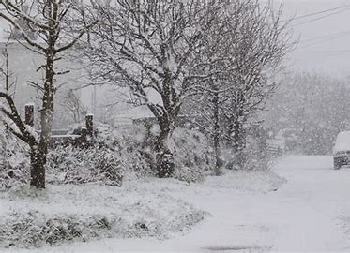
Foundation Spring First Half Curriculum Overview
Themes
Winter
New Year
Chinese New Year
Communication & Language
Taking turns to speak and listen to each other

Personal, Social and Emotional Development
Self awareness and understanding own feelings, Peaceful Problem Solving

Kea Values
Ready
We have good manners

Respectful
We are kind
Safe
We follow instructions

Expressive Arts and Design
Art: Observational art, cool and warm colours, oil pastel techniques
Songs, rhymes and dynamics

Understanding the world
Winter, birds, weather, cold climates, nocturnal animals

Maths
Numbers to 10, addition and subtraction, measures of length, time and mass.

Literacy
A sentence
Phonic scheme – Read Write Inc Set 2 sounds

Physical Development
Ball Skills, Gymnastics

Key Texts
Lost and Found
Snowy Bears
One Snowy Night
Penguin Small
Percy Park Keeper
Bible Story – Noah’s Ark

