Plan for Thursday 21st October
Before play time today we will be completing the instruction writing on “How to trap a Troll”.
If you have already completed this at home, then you might like to try the maths sheet provided, this will give you some revision on the work we have been doing recently.
After play we will be going swimming.
This afternoon, the class will be having a music lesson with Miss Reeve. An alternative for home learning is to follow this link to a piece of music called “In the Hall of the Mountain King” It tells the story of a young man who is trapped underground by the King of the Trolls. You can then draw a picture of the story inspired by the music.
We will be completing the afternoon with PSHE looking at how we interpret feelings
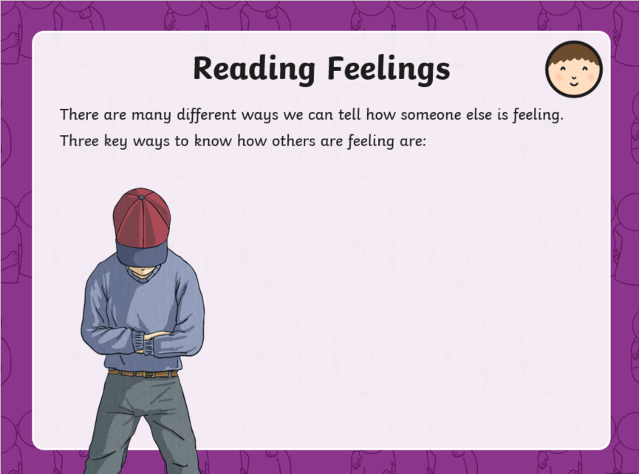
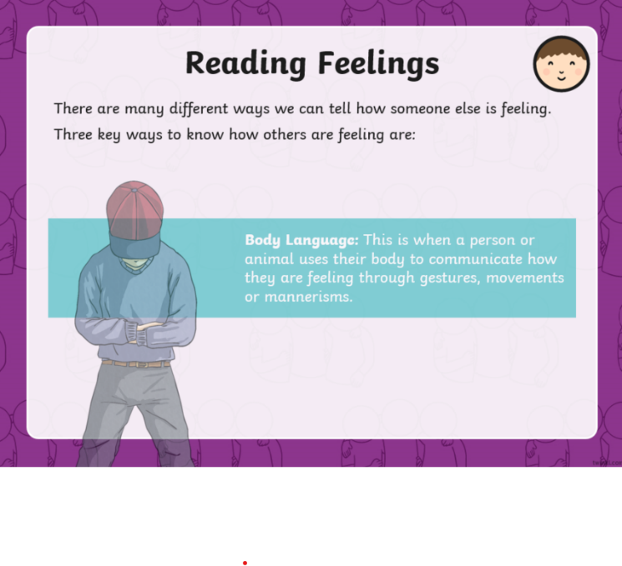
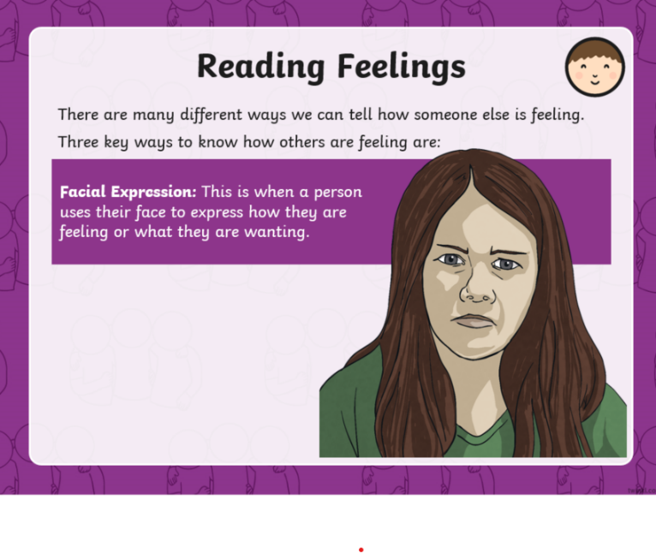
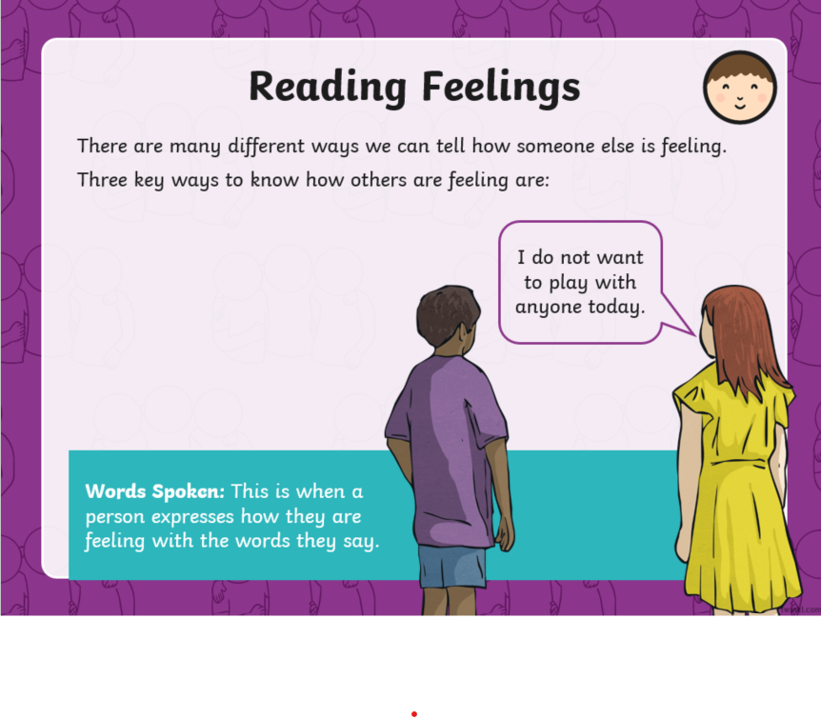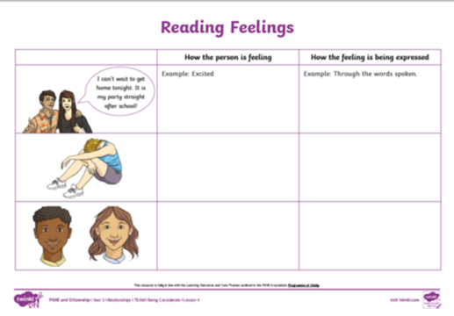
Finally, complete the activity on the worksheet (you do not need to print the sheet unless you want to.)

