Year 1 Show and Tell Homework 4.12.20
This week we would like you to think about Christmas traditions. What do you do each year to make Christmas special? Can you draw a picture or write about how your family celebrates Christmas?
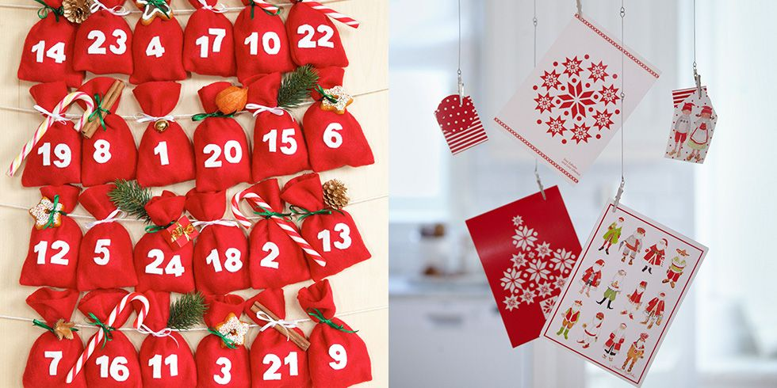
Year 1 Show and Tell Homework 4.12.20
This week we would like you to think about Christmas traditions. What do you do each year to make Christmas special? Can you draw a picture or write about how your family celebrates Christmas?

