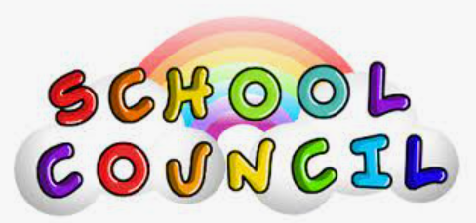
This year, School Council will continue to be run by Mrs McPherson. I am very much looking forward to having regular meetings in person.
Your first challenge is to elect your new representatives. If you are interested in applying (and you were not on the School Council last year) we would like you to do the following: Write an idea to improve the well-being of pupils at our school. You could talk about this to your class and then the best idea will be voted for and the new reps created.
Your ideas will then be shared at the first school council meeting and any which are possible to carry out, will be presented to Mrs Hunkin and Mr Barritt to decide on the most suitable ones.
I will need the names of two children from each class who received the most votes by Friday 24th September.
We feel it is important for us all to feel that sense of community and togetherness again.
Good luck and I can’t wait to have a School Council again and lots of fun for our school.
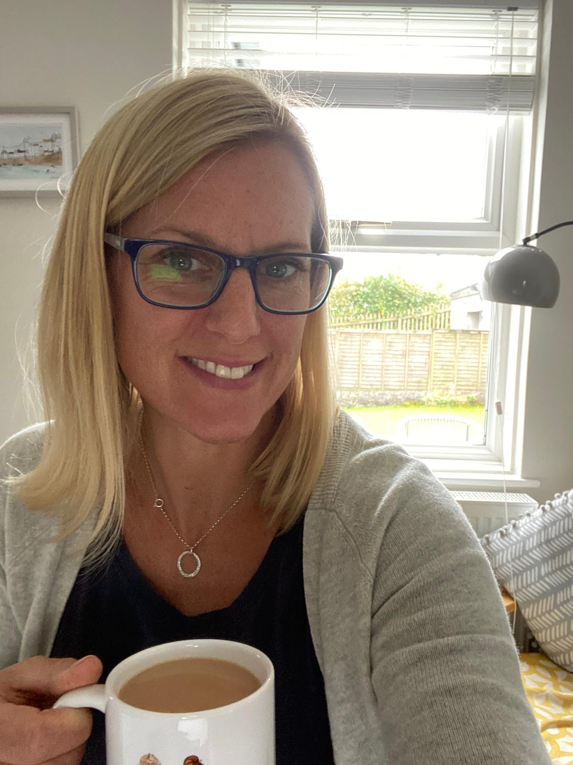
Mrs McPherson

