Children in Need 2020

We had a wonderful celebration of all things “Pudsey” on Friday 13th November. The children were invited to dress in home clothes, pyjamas or favourite movie characters for the day. Many donated for this.

We also had a colouring and drawing competition which was 50p to enter. Well done to the winners of this competition with their wonderful Pudseys .
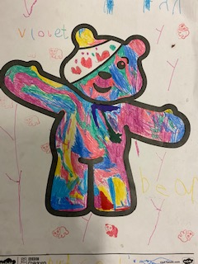
Violet in Foundation Class
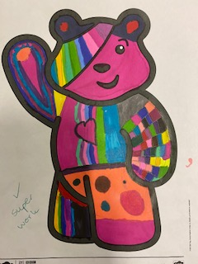
Veryan in Year 1
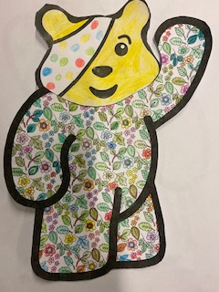
Tristan in Year 2
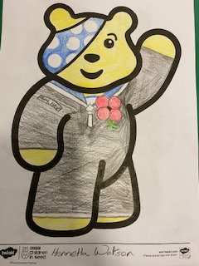
Henrietta in Year 6

