Show and Tell Homework 13.11.20
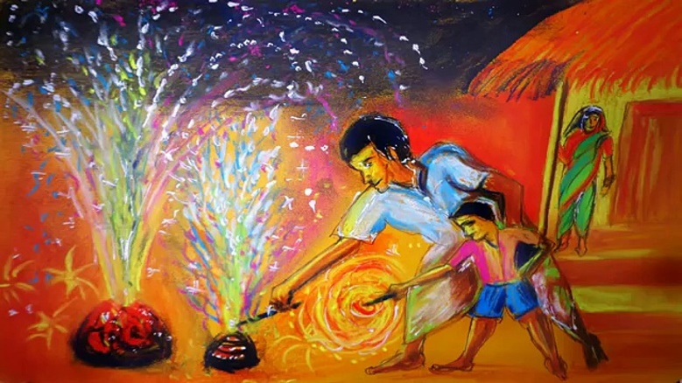
This Saturday is Diwali, the biggest celebration of the year for Hindus. This week we would like you to draw a picture of Diwali being celebrated somewhere around the UK. You can use the internet to help you search for ideas.
Happy Diwali!

Show and Tell Homework 13.11.20
This Saturday is Diwali, the biggest celebration of the year for Hindus. This week we would like you to draw a picture of Diwali being celebrated somewhere around the UK. You can use the internet to help you search for ideas.
Happy Diwali!

