Homework - Friday 7th May 2021 - Summer Term week 3

Reading –
Please read for at least 30 minutes each school day
Literacy –
This week, we have been learning about Ancient Greece, and writing our own Greek myths.
Invent a mythical creature, write a description of where it lives, what it eats, what it looks like and describe how it behaves. You need to aim to write at least one side of A4. You can draw your creature and colour it in, only after your writing is finished. You can research mythical creature if you wish, but please create your own unique one, not one already featured in a story.
Maths
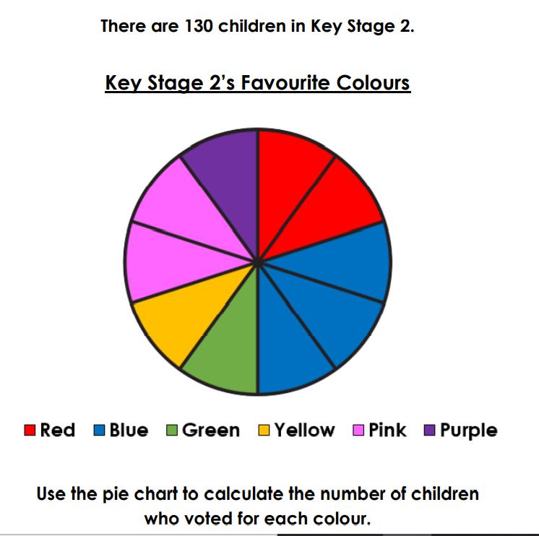
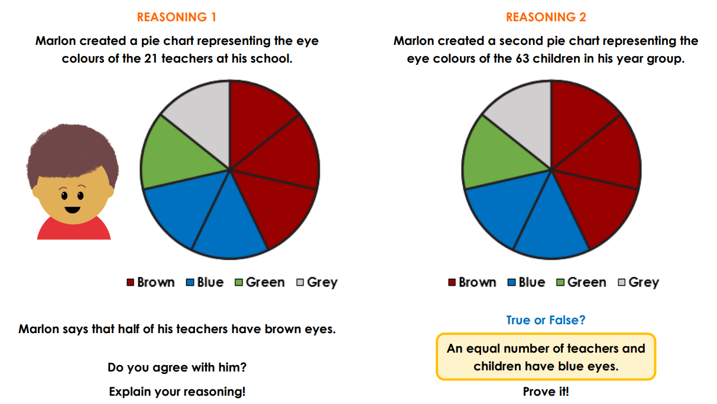

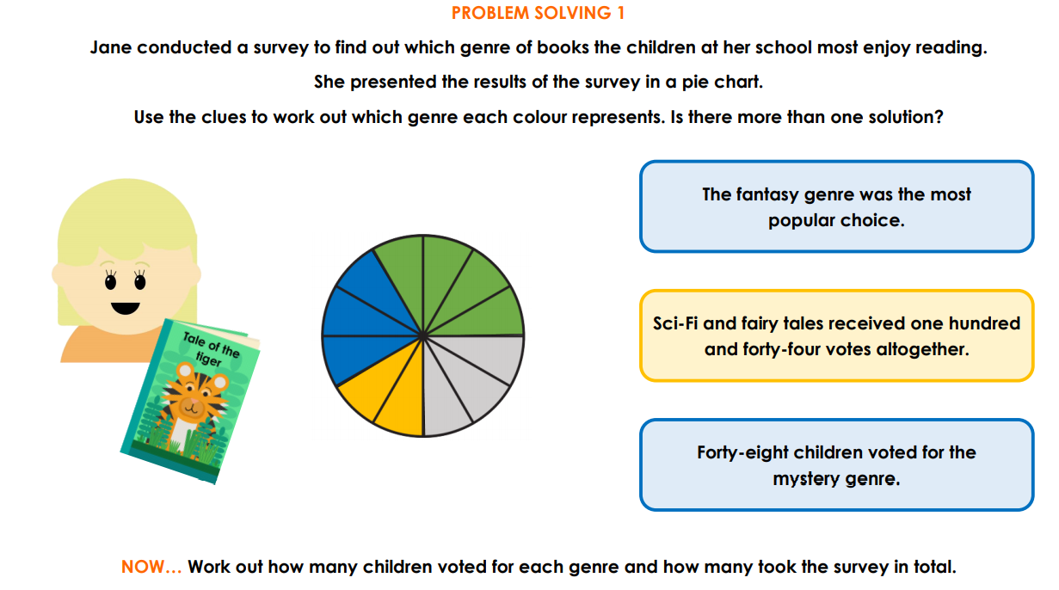
Try to complete as much as you can from the activities above

