30.4.21 Show and tell homework – Tens and ones.
We would like you to play a game with coins. We do not need you to record anything for this, just ask an adult to write how you found it. First, get up to six coins and look carefully at which side is the tail and which side is the head. You may need an adult to show you this.
Heads Tails
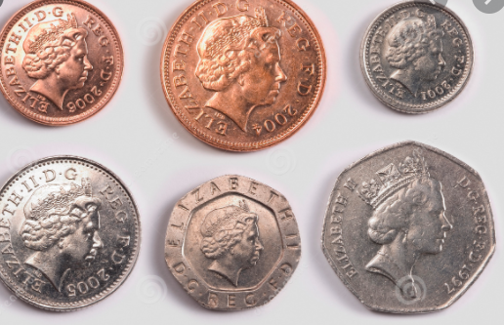 | 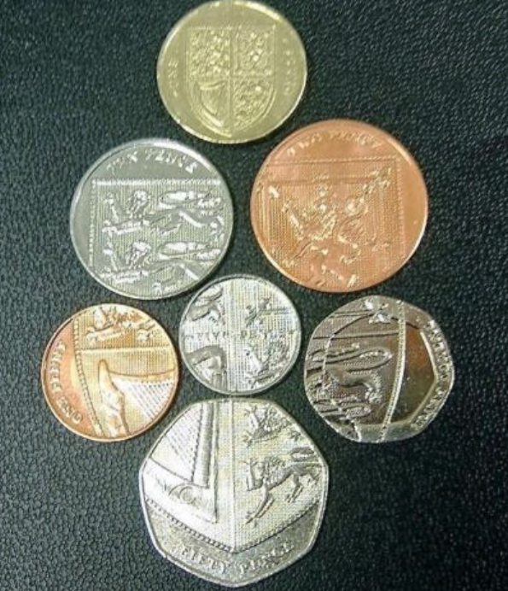

To play the game
- The first person takes a turn by gently dropping or throwing the handful of coins. The ones that land on heads are tens and the ones that land on tails are ones.
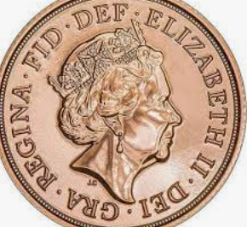 =4 tens
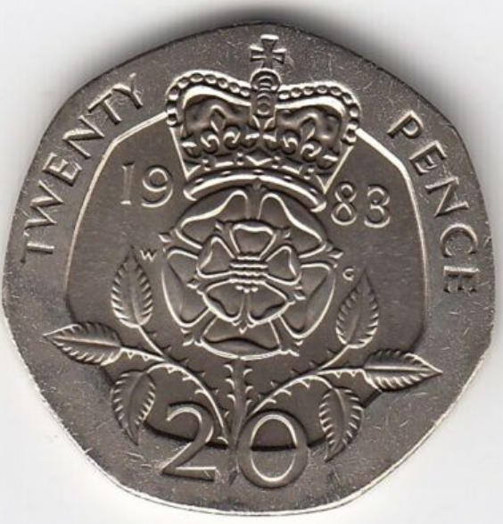 = 3 ones.
- Add the tens and ones together and work out your total.
- The winner is the one with the highest number!
- Repeat the game if desired!
Extension
If you find this too easy, use ten coins to make a potentially larger number.

