Homework Friday 30th April Summer Term week 2

Reading –
Please read for at least 30 minutes each school day
Literacy –
This week, we have been learning about Ancient Greece.
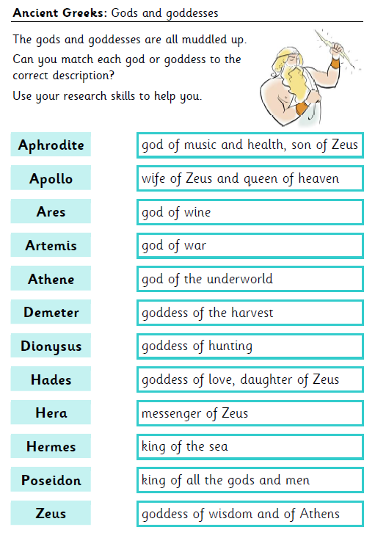
Choose 3 or more that interest you most, draw an image of them from your research and include some more information on each.
Maths
Try to complete all of the revision activities over the course of the week. Work in daily columns or select rows of similar questions and work at your own pace.
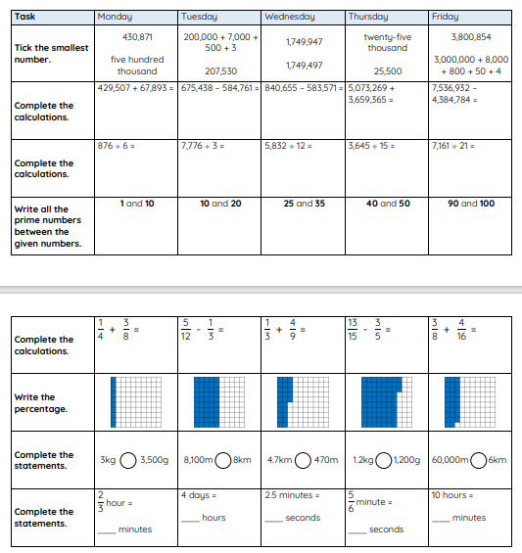

N.B. Parents, please use the answer sheet separately posted

