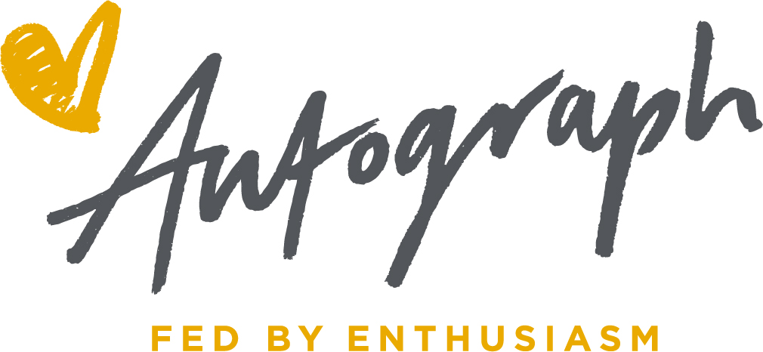

Dear Parent/Carer

Your child is soon to go on a school trip; we would like to take this opportunity to offer you the option to order a tasty healthy and nutritious packed lunch.

The lunch includes a variety of options plus a drink of juice; just fill in the tick list below by selecting one choice from each of the four groups and return it to the school by ==== Please remember to go on to ParentPay and order and pay for the packed lunch. You will need to do this by selecting the main meal option for the same date that the packed lunch is required. Please note that ParentPay will not have the packed lunch option available for you to select.

If your child is entitled to a Free School Meal or is in Key Stage 1 there will be no charge.
Date of packed lunch: 23.03.2022
Name
Class: Year 3
Group1
Cheese Sandwich
Tuna Sweetcorn Mayo sandwich
Egg and Salad sandwich
Cheese and Tomato sandwich
Group 2
Carrot and cucumber sticks
Cherry tomatoes
Group 3
Apple
Banana
Pear
Group 4
Biscuit
Slice of cake
Group 5
Orange cuplet drink
Apple cuplet drink

