25.6.21 Show and Tell Homework
Simple Arrays for Multiplication
What is an array?
An array in maths is an arrangement of objects, numbers or pictures in columns or rows. The purpose of an array is to help children understand multiplication and division.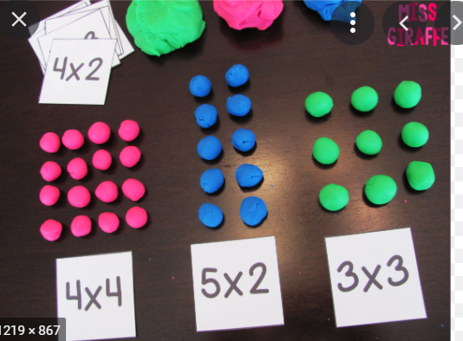

Can you use playdough, Lego, beads, raisins, pasta or anything else to make an array? Can you find things that are in an array pattern, such as an egg box, bar of chocolate or muffin tin?
- Can you tell an adult how many rows there are?
- Can you tell an adult how many are in each row?
- Can you tell an adult how many there are altogether?
Challenge: Can you tell an adult what the multiplication sum is?
You can draw this, do it and take a photo or do it and ask an adult to write a little comment about how you got on. Good Luck!

