Dear Parents and Carers,
We hope you find this guide to Read Write Inc and reading useful. It will set out where you can access phonics teaching and reading material during these challenging times. There’s quite a bit of information to take in, but we feel it is helpful and will hopefully guide you. Please don’t be overwhelmed. Just try to do what you can.
Read Write Inc Phonics
In reading, the children in Foundation are naturally working at different levels. Some children are still consolidating their Set 1 sounds until secure. The Set 1 sounds are as such:
m a s d t, i n p g o, c k u b, f e l h sh, r j v y w, th z ch qu x ng nk.
Some children who are secure in these sounds are ready to learn their Set 2 sounds. These are the long vowel sounds and are:
ay ee igh ow (as in blow) oo (as in zoo)
oo (as in look) ar or air ir ou (as in out) oy
There is no rush to progress through these sounds. It is much better to master Set 1 before moving onto Set 2.
Daily RWI tasks
We would like you to follow the daily Oxford Owl Read Write Inc phonics videos that are put on You Tube. These videos come on at 9.30am and are available for 24 hours. These are excellent and are enjoyed by children. The teachers are so enthusiastic, mesmerising and fun – I think the children will love them. They also progress step by step, day by day, building on the children’s previous learning.
They cover the speed sounds, writing, reading and spelling. There are Set 1 and Set 2 videos each day. Children should not be doing both Set 1 and Set 2. We will send a Tapestry message to suggest which set we would like you to watch. Of course, we are not going to hold you up if you would like to move onto set 2 should you wish, or would like to consolidate Set 1.
To find these videos please follow this link:
https://www.youtube.com/channel/UCo7fbLgY2oA_cFCIg9GdxtQ?mc_cid=71ef745098&mc_eid=c9705b8c67
Reading
We would like the children to be reading something daily to an adult, just like when at school. There are a supply of reading scheme books in reception at school. You can come and change the books there, making sure you return them in the returns box.
However, there are some really good free reading books on the internet.
We recommend you registering on the ‘Oxford Owl’ website as an adult. It is free. Here, you can access an online reading ebook library.
Once registered, find the ebook page, which should look like this:
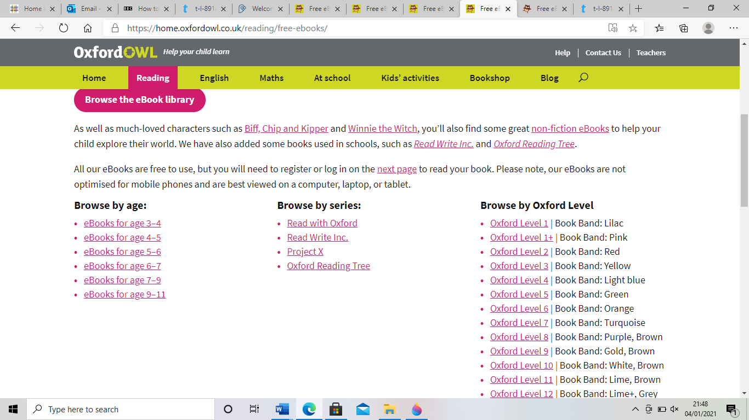
On the right-hand side of the page, you can browse books by the Oxford colour level. In the middle of this page you can see ‘Browse by series’ column. Click on ‘Read Write Inc’. The sound blending books are great and children in YF can start to read the red level ditty books.
Please note that there is no rush for children to progress through the different levels of reading books. Choosing books from the pink level Oxford Reading Tree is where many children should be. Of course, you can judge if your child needs to progress further or at a slower pace – they are all at different stages of development, and, as we can’t see many children face to face, we encourage you to follow your children’s progress. It is really important that their comprehension skills develop, not just their decoding skills, hence no need to rush through the levels.
Phonics Play decodable comics are also brilliant. Here, you can access a lovely selection of comics to read (for free!). You can find these by going here: https://phonicsplaycomics.co.uk/
You can also find reading in everyday life. Children can enjoy trying to read labels, captions, signs, posters, recipes and shopping lists.
Red Words
Keep reading these words at the front of your reading record. They are words that the children just need to know. There are two sets of these words. Work through set 1 first. If your child is confident at these, you could try to learn a few of the set 2 words. Again, there is no rush as we don’t expect them to know set 2 yet.
These words are on the website in general literacy resources.

