Geography Progression of Skills Year A
This document sets out the skills taught in geography for each year group. The highlighted skills are those that are compulsory according to the national curriculum, the ones not highlighted are suggestions for study. The colours of highlighting suggest which skills fit best with which topic, but all should be covered during the year.
 | EYFS | Year 1 | Year 2 |  | Year 3 | Year 4 | Year 5 |  | Year 6
WHOLE SCHOOL TOPICS |  | Myths and Legends (Aut 1)  Winter Festivals (Aut 2)  Clothes over Time (Spring 1)  Marvellous Maps (Spring 2)  Fabulous Food (Summer 1)  Beside the Sea (Summer 2) |  | Victorians (Aut 1)  Festivals and Faiths (Aut 2)  Ancient Rome (Spring 1)  Looking after our World (Spring 2)  Maps and Mapping (Summer 1)  Cousin Jacks (Summer 2)
READING ACROSS THE CURRICULUM | 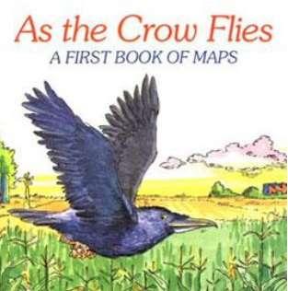 | 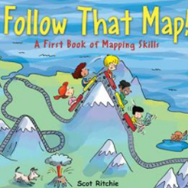 | 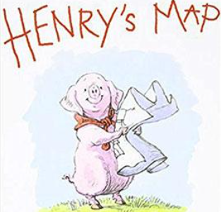 |  | 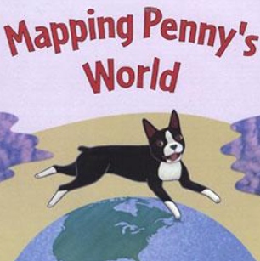 | 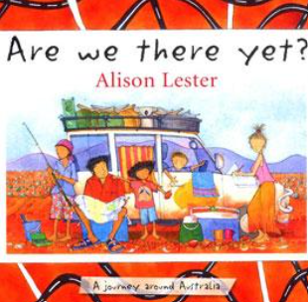 | 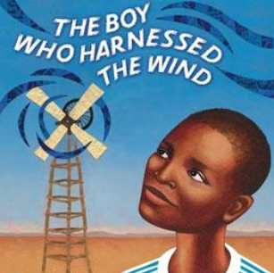 |  | 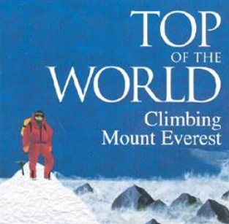
VOCABULARY |  | United Kingdom, North Pole, South Pole, Equator, country, oceans;  Atlantic, Pacific, Indian, Southern, Arctic. Continents – Europe, Africa, Antarctica, Asia, Australasia, North and South America.  England, Scotland, Wales and Northern Ireland.  Beach, cliff, coast, forest, hill, mountain, sea, ocean, river, soil, valley, vegetation, season, weather.  City, town, village, factory, farm, house, office, port, harbour, shop.  Map, atlas, globe.  Compass – North, South, East, West. Near, far, left, right. |  |  | Building upon vocabulary gained in KS1, then expanding it to include:  Latitude, longitude, Equator, Northern Hemisphere, Southern Hemisphere, the Tropics of Cancer and Capricorn, Arctic and Antarctic Circle,  Climate zones, sustainability, pollution, climate emergency.  River, erosion, coasts, confluence, tributary, mountains, volcanoes, earthquakes.  The water cycle.  Settlements, urban, rural, land use, economic activity, natural resources including energy, food, minerals and water.  Eight compass points, six figure grid reference, four figure grid reference  contour |  |  | Recapping vocabulary gained in LKS2, then expanding it to include:  the Prime/Greenwich Meridian and time zones (including day and night).  Human and physical geography. Biomes and vegetation belts, trade links.  Deposition, transportation, long shore drift, headland rivers.  Sixteen compass points, six figure grid reference,
KNOWLEDGE AND UNDERSTANDING (local knowledge) |  | Use simple geographical vocabulary to describe features or location e.g. hill, local, a road, coastline, woods.  Consider geographical questions e.g. what is it like to live in this place?  Express own views about a place, people, environment.  Recognise how places have become the way they are e.g. shops.  Observe and record e.g. identify buildings on a street  Communicate in different ways e.g. pictures, pictograms simple maps, sketches, labelled diagrams.  Name the four seasons and describe typical weather conditions for each.  Identify hot and cold areas in the world and begin to understand climate in simple terms – e.g. consider what they might wear if they lived in a very hot or a very cold country.  Name the four countries of the UK.  Name some of the main towns and cities in the United Kingdom  Describe in simple terms how wind or water has affected the Geography of an area.  Answer simple questions regarding straight forward geographical patterns (e.g. what are the busiest times at the park?)  Identify similarities and differences between the local environment and one other place. | Describe key features of a place, using words like, beach, coast, forest, hill, mountain, ocean, valley, farmland, woods, coastline, local, vegetation, cliff, sea, season.  Consider geographical questions – Where is this place? What is it like? How has it changed?  Express own views and preferences about a place, people, environment, location and give detailed reasons.  Recognise how places have become the way they are e.g. shops.  Observe and record in different ways e.g. sketches, diagrams, ICT, charts.  Compare and describe an area of the UK to a place outside Europe using geographical words.  Explain how the jobs people do may be different in different parts of the world.  Explain what facilities a town or village might need.  Use information texts and the web to gather information about the worlds human and physical geography.  Suggest ways of improving the local environment.  Describe how a physical or human process has changed an aspect of the local environment – consider questions such as “Do you think that people ever spoil the area or make it better?” “How?”  Use compass directions (N, S, E, W) to describe locations. |  | Describe route and direction using 8 compass points e.g. N, S, E, W, NW, NE, SW, SE.  Link words to topic e.g. river, meander, flood, plain, location, industry. Transport.  Use correct geographical words to describe a place and the things that happen there.  Use technical and geological vocabulary to describe physical processes.  Ask geographical questions: where is this location? What do you think about it? •  Analyse evidence and draw conclusions e.g. make comparisons between locations using photos, pictures, temperatures, population.  Identify and explain different views of people including themselves e.g. views of different sections of community when developing holiday resort, new housing estate. •  Hold geographical debate through drama and role play (e.g. recycling)  Collect and record evidence: e.g. construct questionnaire, field sketch, brainstorm words about a place, e-learning, atlases.  Communicate in ways appropriate to task and audience e.g. use questionnaires, charts, graphs to show results, write views to local paper.  Describe how volcanoes are created  Describe how earthquakes are created.  Locate the Mediterranean and explain why it is a popular holiday destination.  Name a number of countries in the Northern Hemisphere.  Describe and compare different features of human and physical geography of a place, offering explanations for the locations for some of these features.  Name and locate vegetation belts across the UK, explaining how some of these have changed over time.  Identify how people both damage and improve the environment.  Provide a reasonable explanation for features in relation to location (e.g. the shops out of town are bigger because there is more space)  Sequence and explain features of a physical weather process, such as the water cycle.  Identify changes in the local and global environment. | Describe route and direction linking N/S/E/W with degrees on the compass. •  Link words to topic e.g. contour, height, valley.  Ask questions – what is this landscape like? what will it be like in the future?  Analyse evidence and draw conclusions e.g. make comparisons between locations using photos, pictures and maps.  Identify and explain different views of people including themselves.  Collect and record evidence: show questionnaire results in simple chart or colour coded maps which demonstrate patterns.  Communicate in ways appropriate to task and audience.  Carry out research to discover features of cities and villages.  Plan a journey to a place in England.  Explain why people are attracted to living in cities.  Explain why people may choose to live in a village rather than a city.  Know the difference between the British Isles, Great Britain and UK.  Know the countries that make up the European Union.  Name the areas of origin of the main ethnic groups in the UK and in their school.  Collect and analyse data from first and second hand sources, identifying and analysing patterns and suggesting reasons for them (e.g. a number of hotels and restaurants are found at the seaside).  Describe how physical activity has impacted and/or changed the physical and human characteristics of a place in the world.  Name the rivers of the UK and describe the impact on the human and physical geography of the places they are found.  Explain how people try to sustain environments.  Describe how physical processes have changed the characteristics of a landscape, country or continent and how it can affect the lives and activities of the people living there.•  Describe and explain how the climate of a country or continent is linked to the distribution of natural resources and tourism.  Compare and contrast how areas of the world have capitalised on their physical and human features | Describe route, direction and location, linking 8 points of compass to degrees on compass.  Link words to theme e.g. river – erosion, deposition, transportation, coasts, long shore drift, headland.  Ask questions: what is this landscape like? how has it changed? what made it change? how is it changing?  Analyse evidence and draw conclusions e.g. compare historical maps of varying scales, temperature of various locations and its influence on people.  Identify and explain different views of people including themselves.  Design and use questionnaires to obtain views of community on subject.  Collect and record evidence.  Conduct a land use survey.  Communicate in ways appropriate to task and audience e.g. persuasive writing – present information on map overlays to show levels of information e.g. old/new.  Plan a journey to a place in another part of the world, taking account of distance and time.  Explain why many cities of the world are situated by rivers and why this makes it an attractive location. •  Explain how a location fits into its wider geographical location; reference to human and economical features. |  | Describe route, direction location linking 16 points on compass to degrees on compass.  Link words to theme e.g. settlement, urban, rural, land use, sustainability, rivers, confluence, tributary.  Ask questions: what is this landscape like? how is it changing?  What patterns can you see/ how has the pattern changed?  Analyse evidence and draw conclusions e.g. from field work data on land use comparing land use and temperature.  Look for patterns and explain reasons behind them. •  Identify and explain different views of people including themselves and justify in detail.  Communicate in ways appropriate to task and audience e.g. use email to exchange information about locality with another school.  Give an extended description of the human features of different places around the world.  Describe how some places are similar and others are different in relation to their physical features.  Name the largest desert in the world.  Explain how the time zones work.
KNOWLEDGE AND UNDERSTANDING (fieldwork techniques) |  | Use simple field sketches use a camera.  Keep a weather chart and answer questions about the weather.  Use maps, pictures and stories to find out about different places.  Collect data during fieldwork such as the number of trees/houses in school environment.  Recognise simple human and physical features on an aerial photograph or simple map, showing an awareness that objects look different from above. | Use simple field sketches and diagrams, use a camera.  Use plan view or aerial photos to recognise landmarks and to describe geographically the human and physical features.  Collect and organise simple data from first and second hand sources including fieldwork.  Explain simple patterns and offer an explanation (e.g. count traffic and offer and explanation as to why. the flow changes at different times) |  | Draw and use more detailed field sketches and diagrams, using symbols for a key.  Observe, measure and record the human features in the local area responding to a range of geographical questions.  Locate appropriate information, needed for a task, from a source material. | Accurately measure and collect information (e.g. rainfall, temperature, wind speed, noise levels etc.)  Suggest which source material to use for a specific task, locating the information needed.  Suggest where in the world an aerial photo or satellite image shows, explaining reasons for their suggestions. | Field sketches should show understanding of pattern, movement and change.  Draw in scale – accuracy of scale locate information/ place with speed and accuracy use key to make deductions about landscape/ industry/ features etc. |  | Field sketches should show understanding of pattern, movement and change.•  Use maps, aerial photos, plans and web resources to describe what a locality might be like.
PRACTICAL GEOGRAPHY (map and atlas skills) |  | Make simple maps and plans.  Explore maps of the local area.  Draw a simple picture map (could be from a story) and label particular features.  Locate the four countries of the United Kingdom on a map.  Locate hot and cold areas of the world on a map. | Compare two settlements using globes, maps, plans (at a range of scales).  Use contents/index to locate a country and draw information from a map.  Name the continents of the world and find them in an atlas.  Name the world’s oceans and find them in an atlas.  Name and locate the main cities of England, Wales, Scotland and Ireland.•  Find where they live on a map of the UK.  Identify the seas which surround the UK.  Use simple compass directions and locational/directional language when using maps.  Draw simple maps or plans using symbols for a key.  Locate the equator and North and South Poles and explain how the weather affects these areas. |  | Draw maps more accurately plan view (from above) and use a key accurately.  Use maps and atlases appropriately by using contents and indexes.  Use some basic OS map symbols.  Understand and use 4 figure grid references.  Name up to six cities in the UK and locate them on a map.  Locate and name some of the world's most famous volcanoes.  Use eight points of a compass to describe the location of a country or geographical feature.  Locate and explain the significance of the Northern and Southern hemispheres and the Arctic and Antarctic Circles. | Draw an accurate map – develop more complex key use contents/index to locate position of location including page/coordinates.  Locate the Tropic of Cancer and the Tropic of Capricorn.  Name and locate the capital cities of neighbouring European countries.  Locate and name some of the main islands that surround the UK.  Draw sketch maps and plans using standardised symbols and key.  Locate and name geographical features on an Ordnance Survey map.  Understand and use 6 figure grid references.  Plot a route on a map or a globe, from one place to another, identifying countries or significant landmarks that are passed.  Locate and explain the significance of the Equator, Northern Hemisphere, Southern Hemisphere, the Tropics of Cancer and Capricorn to a range of countries across the world.  Locate the countries of Europe, North and South America. | Name and locate many of the world’s major rivers on maps.  Name and locate many of the world’s most famous mountain regions on maps.  Locate the USA and Canada on a world map and atlas.  Locate and name the main countries in South America on a world map and atlas. |  | Locate information/ place with speed and accuracy use key to make deductions about landscape/ industry/ features etc.  Use OS maps to answer questions.  Recognise key symbols used on ordnance survey maps.  Identify and name the Tropics of Cancer and Capricorn as well as the Arctic and Antarctic circles.  Use eight points on a compass.

