History Progression of Skills Year A
 | Foundation | Year 1 |  | Year 2 |  | Year 3 |  | Year 4 |  |  | Year 5 |  | Year 6
WHOLE SCHOOL TOPICS |  | Myths and Legends (Aut 1)  Winter Festivals (Aut 2)  Clothes over Time (Spring 1)  Marvellous Maps (Spring 2)  Fabulous Food (Summer 1)  Beside the Sea (Summer 2) |  |  |  | Victorians (Aut 1)  Festivals and Faiths (Aut 2)  Ancient Rome (Spring 1)  Looking after our World (Spring 2)  Maps and Mapping (Summer 1)  Cousin Jacks (Summer 2)
READING ACROSS THE CURRICULUM | 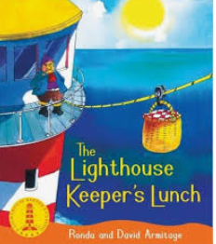 | 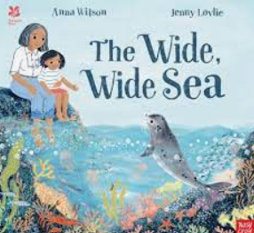 | 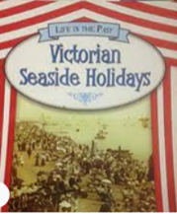 |  | 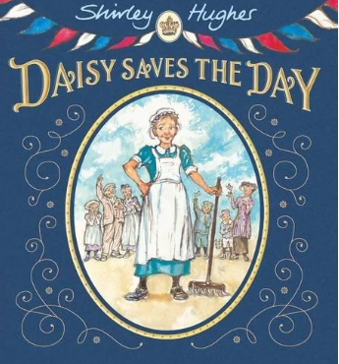 |  | 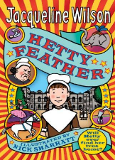 |  | 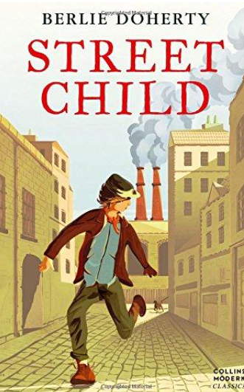 |  |  | 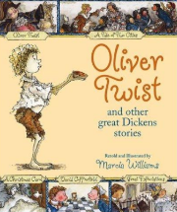
AREAS OF STUDY (A.O.S) | - Talk about the lives of people around them and their roles in society. Know some similarities and differences  - between things in the past and now, drawing on their experiences and what has been read in class. Understand the past through settings, characters and events encountered in books read in class and storytelling. | - Changes within living memory. Where appropriate, these should be used to reveal aspects of change in national life. (at least 1)  - Events beyond living memory that are significant nationally or globally. (at least 2)  - The lives of significant individuals (at least 2) in the past who have contributed to national and international achievements. Some should be used to compare aspects of life in different periods.  - Significant historical events, people and places in their own locality. (at least 1) |  |  |  | - Changes in Britain from the Stone Age to the Iron Age  - The Roman Empire and its impact on Britain  - Britain’s settlement by Anglo-Saxons and Scots  - The Viking and Anglo-Saxon struggle for the Kingdom of England to the time of Edward the Confessor  - A local history study  - A study of an aspect or theme in British history that extends pupils’ chronological knowledge beyond 1066  - The achievements of the earliest civilizations – an overview of where and when the first civilizations appeared and a depth study of one of the following: Ancient Sumer; The Indus Valley; Ancient Egypt; The Shang Dynasty of Ancient China  - Ancient Greece – a study of Greek life and achievements and their influence on the western world  - A non-European society that provides contrasts with British history – one study chosen from: early Islamic civilization, including a study of Baghdad c. AD 900; Mayan civilization c. AD 900; Benin (West Africa) c. AD 900-1300.
Statutory vocabulary across Key Stages:  “gain and deploy a historically grounded understanding of abstract terms such as ‘empire’, ‘civilisation’, ‘parliament’ and ‘peasantry’” | today yesterday tomorrow  the present the past the future  day week month calendar  long ago old new/recent  parent grand parent great grand parent  materials plastic  clue memory lifetime  Who? What?  remember | Year decade century ancient modern long ago  timeline date order  similar different  living memory  remembers 1960s  grandparents’ time the older generation memories  materials wood plastic  drawing photograph camera detective investigate historians research evidence  opinion artefact  What…? When…? Where…? |  |  |  | Chronological order Historical period  B.C (Before Christ)  A.D (Anno Domini)  millennium thousands of years  Roman Britain Empire Tribe  Invasion Settlement  Caesar civilisation/civilised chariot colosseum  Poverty emigration industry livelihood  Tin/copper ore Engine House Beam Engine Shaft Stope Adit Fuse  Navvies Workhouse Shilling Servant Factory Railway  Variety of sources  this source suggests that..…  primary evidence eye witness  Secondary evidence could have been might have been  this source suggests that… this source doesn’t show  that… |  |  |  | anachronism chronological order era/period  B.C.E (Before the Common  Era)  C.E (The Common Era) B.C (Before Christ)  A.D (Anno Domini) millennium thousands of years  Roman Britain Empire Tribe  Invasion Settlement  Caesar civilisation/civilised Massacre Chariot Colosseum Tyranny Cult  Poverty emigration industry livelihood  Tin/copper ore Engine House Beam Engine Shaft Stope Adit Fuse  Man Engine  Typhoid Navvies Workhouse Cholera Shilling Servant Factory Mill Railway  Variety of sources  Different experiences  this source suggests that..  I can infer that… impression the source omits to mention  Reliability propaganda  Bias/biased  primary evidence eye witness  Secondary evidence could have been might have been  this source suggests that… this source doesn’t show  that…
Chronological understanding |  | Understand the difference between things that happened in the past and the present.  Describe things that happened to themselves and other people in the past.  Order a set of events or objects  Use a timeline to place important events.  Use words and phrases such as: now, yesterday, last week, when I was younger, a long time ago, a very long time ago, before I was born. When my parents/carers were young |  | Understand and use the words past and present when telling others about an event.  Recount changes in my own life over time.  Understand how to put people, events and objects in order of when they happened, using a scale the teacher has given me.  Use a timeline to place important events. |  | Understand that a timeline can be divided into BC (Before Christ) and AD (Anno Domini)  Use a timeline to place historical events in chronological order.  Describe dates of and order significant events from the period studied. (refer to KIRFS) |  | Understand that a timeline can be divided into BC (Before Christ) and AD (Anno Domini)  Order significant events and dates on a timeline.  Describe the main changes in a period in history. |  |  | Understand that a timeline can be divided into BC (Before Christ) and AD (Anno Domini) and that these can also be known as B.C.E (Before the Common Era) C.E (The Common Era)  Order significant events, movements and dates on a timeline.  Describe the main changes in a period in history. |  | Understand that a timeline can be divided into BC (Before Christ) and AD (Anno Domini) and that these can also be known as B.C.E (Before the Common Era) C.E (The Common Era)  Order significant events, movements and dates on a timeline.  Identify and compare changes within and across different periods.  Understand how some historical events occurred concurrently in different locations i.e. Ancient Egypt and Prehistoric Britain.
Knowledge and understanding of events, people and changes in the past |  | Recall some facts about people/events before living memory  Say why people may have acted the way they did. |  | Use information to describe the past.  Describe the differences between then and now.  Look at evidence to give and explain reasons why people in the past may have acted in the way they did.  Recount the main events from a significant event in history. |  | Use evidence to describe the culture and leisure activities from the past.  Use evidence to describe the clothes, way of life and actions of people in the past.  Use evidence to describe buildings and their uses of people from the past |  | Use evidence to describe what was important to people from the past.  Use evidence to show how the lives of rich and poor people from the past differed.  Describe similarities and differences between people, events and artefacts studied.  Describe how some of the things I have studied from the past affect/influence life today. |  |  | Choose reliable sources of information to find out about the past.  Give own reasons why changes may have occurred, backed up by evidence. For example religious practices in Britain between the Roman invasion and 1066  Describe similarities and differences between some people, events and artefacts studied  Describe how historical events studied affect/influence life today.  Make links between some of the features of past societies. (e.g. religion, houses, society, technology.) |  | Choose reliable sources of information to find out about the past.  Give reasons why changes may have occurred, backed up by evidence. For example religious practices in Britain between the Roman invasion and 1066  Describe similarities and differences between some people, events and artefacts studied.  Describe how some of the things studied from the past affect/influence life today.  Make links between some of the features of past societies. (e.g. religion, houses, society, technology.)
Historical interpretation |  | Look at books, videos, photographs, pictures and artefacts to find out about the past. |  | Look at and use books and pictures, stories, eye witness accounts, pictures, photographs, artefacts, historic buildings, museums, galleries, historical sites and the internet to find out about the past. |  | Explore the idea that there are different accounts of history. |  | Look at different versions of the same event in history and identify differences.  Know that people in the past represent events or ideas in a way that persuades others. |  |  | Understand that some evidence from the past is propaganda, opinion or misinformation, and that this affects interpretations of history.  Give reasons why there may be different accounts of history.  Evaluate evidence to choose the most reliable forms. |  | Evaluate evidence to choose the most reliable forms.  Know that people both in the past have a point of view and that this can affect interpretation.  Give clear reasons why there may be different accounts of history, linking this to factual understanding of the past.

Historical Enquiry |  | Identify different ways in which the past is represented  Explore events, look at pictures and ask questions i.e, “Which things are old and which are new?” or “What were people doing?”  Look at objects from the past and ask questions i.e, “What were they used for?” and try to answer. | Identify different ways in which the past is represented.  Ask questions about the past.  Use a wide range of information to answer questions | Use documents, printed sources (e.g. archive materials) the Internet, databases, pictures, photographs, music, artefacts, historic buildings, visits to museums and galleries and visits to sites as evidence about the past.  Ask questions and find answers about the past | Use documents, printed sources (e.g. archive materials) the Internet, databases, pictures, photographs, music, artefacts, historic buildings, visits to museums or galleries and visits to sites to collect evidence about the past.  Ask questions and find answers about the past. | Use documents, printed sources (e.g. archive materials) the Internet, databases, pictures, photographs, music, artefacts, historic buildings, visits to museums and galleries and visits to sites to collect evidence about the past.  Choose reliable sources of evidence to answer questions, realising that there is often not a single answer to historical questions.  Investigate own lines of enquiry by posing questions to answer. | Use documents, printed sources (e.g. archive materials) the Internet, databases, pictures, photographs, music, artefacts, historic buildings, visits to museums and galleries and visits to sites to collect evidence about the past.  Choose reliable sources of evidence to answer questions, realising that there is often not a single answer to historical questions.  Investigate own lines of enquiry by posing questions to answer.

Organisation and communication |  | Sort events or objects into groups (i.e. then and now.)  Use timelines to order events or objects.  Tell stories about the past.  Talk, write and draw about things from the past. | Describe objects, people or events in history.  Use timelines to order events or objects or place significant people.  Communicate ideas about people, objects or events from the past in speaking, writing, drawing, role-play, storytelling and using ICT | Communicate ideas about the past using different genres of writing, drawing, diagrams, data-handling, drama role-play, storytelling and using ICT. | Communicate ideas about from the past using different genres of writing, drawing, diagrams, data-handling, drama role-play, storytelling and using ICT. | Communicate ideas about from the past using different genres of writing, drawing, diagrams, data-handling, drama role-play, storytelling and using ICT.  Plan and present a self-directed project or research about the studied period. | Communicate ideas about from the past using different genres of writing, drawing, diagrams, data-handling, drama role-play, storytelling and using ICT.  Plan and present a self-directed project or research about the studied period.

