Home Learning Plan
Week beginning: Tuesday 5th January 2021 |  |  | Class: 6
Literacy
Reading |  | Start your day by reading on your own for 10 minutes.  Choose a book at home that you know you can read, remember how we choose a reading book?  Read the first 100 words, make sure you can read and understand 95 out of 100 then the book is a good level for you.
 |  | This week our focus is letter formation and size.
Handwriting |  | 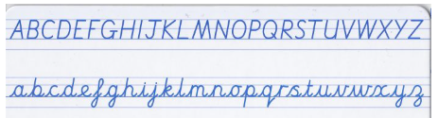
 | Tu  5/1/2021 | Practice writing out the CAPITAL LETTERS from the top line of the picture above.  Do each letter 5 times.
 | W  6/1/2021 | Practice writing out the lower case from the bottom line of the picture above..  Do each letter 5 times.
 | Th  7/1/2021 | Practice writing both lines, CAPITALS and lower case. Write each line twice (four lines in total) Use the picture to prompt you. Check all letters look correct.
 | F  8/1/2021 | Practice writing both lines WITHOUT using the picture to guide you, by now you should know how to do each line neatly. Do one line of CAPITALS, one line of lower case then repeat (four lines in total)
Spelling |  | This week our focus is unusual spelling patterns in words.
 |  | Use the links to the BBC Bitesize spelling activities. Write them and practice each pattern each day.
 | Tu  5/1/2021 | Which words use the 'ough' sound? - BBC Bitesize
 | W  6/1/2021 | Which words end with -cious and -tious? - BBC Bitesize
 | Th  7/1/2021 | How to spell the 'shun' sound - BBC Bitesize
 | F  8/1/2021 | When is the 'sh' sound spelt with 'ch'? - BBC Bitesize
Literacy task |  | This week we are using a unit called Doors.
 | Tu  5/1/2021 | 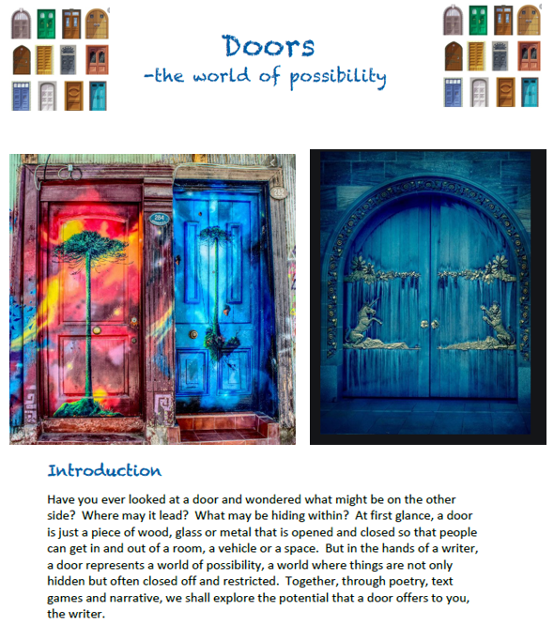  Make a list of all the places you might find behind a door. Don’t be boring, be creative.  (Don’t say “my lounge” or “my garage” because it’s quick and easy to write about real doors. Think about how opening a door could be stepping into a weird, wonderful, imaginative or terrifying place.
 | W  6/1/2021 | Plan a story about you stepping through a door into another place.  Think about the characters, the settings throughout your story and the events of the story in order.  Use a five-part story mountain plan – 1 Opening, 2 Build Up, 3 Problem, 4 Resolution and 5 Ending. Make notes and remember to use Alan Peat grammar features and features from your grammar book.
 | Th  7/1/2021 | Write the first three parts of your story, using your plan from Wednesday.
 | F  8/1/2021 | Finish writing your Doors story, using your plan from Wednesday.  Now, edit your story and make sure you have grammar features in your story.

Maths
Muscle Maths |  | Muscle Maths cards are on the HOME LEARNING tab on the website, click onto Year 6, then GENERAL RESOURCES tab.
Tables |  | Choose from one of these options to practice your tables each day:  - https://www.topmarks.co.uk/maths-games/daily10  - https://urbrainy.com/mtc  - https://www.timestables.co.uk/multiplication-tables-check/
Maths Task

 |  | White Rose/BBC Bitesize/Oak Academy lessons | PowerMaths  pages
 | Tu  5/1/2021 | I can use negative numbers  https://www.bbc.co.uk/bitesize/topics/znwj6sg/articles/zxthnbk
 | W  6/1/2021 | I can transform simple shapes  https://www.bbc.co.uk/bitesize/topics/z2dqrwx/articles/zcjs97h
 | Th  7/1/2021 | I can recognise polygons including circles  https://www.bbc.co.uk/bitesize/topics/zvmxsbk
 | F  8/1/2021 | I can solve practical coordinate problems  https://www.bbc.co.uk/bitesize/topics/zgthvcw/articles/z96k9qt

