Ideas for Maths at Home in Year 2
Place Value | - Use pieces of pasta or bread sticks for tens and dried peas for ones. Make 2 digit numbers, such as 45=4 tens and 5 ones.  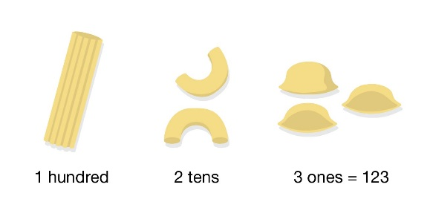  - Draw tens and ones and get your child to tell you what the number is.  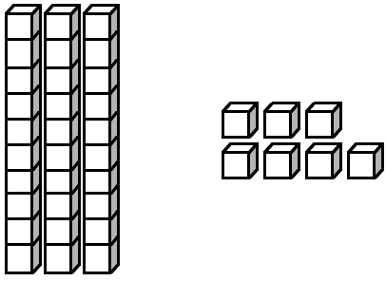  - Draw several numbers with tens and ones and describe one of them. Can they guess which one it is?  - Replace “Guess Who” faces with 2-digit numbers. Ask each other questions about the numbers, such as “Does your number have a 3 in the ones digit?” or “Does your number have 6 tens?”  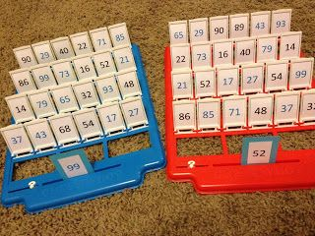  - Make or buy a set of 1-100 number cards. Choose a random selection from the pack and put them in order from lowest to highest. Or highest to lowest. Try to think of numbers which could come between the numbers.  - Roll the dice twice to make a 2-digit number and again to make another one. Put greater than >, less than < or equals sign = in between them. The rule is the crocodile jaws want to eat the bigger number.  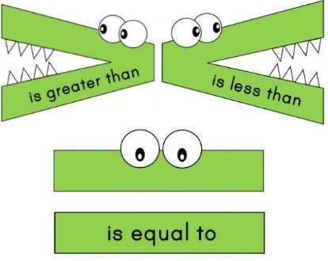
Addition and Subtraction | - Make two 2-digit numbers with pasta. Combine the ones first, then the tens. If the ones add up to more than ten, exchange them for a ten.  - Choose two coins. Record them as tens and ones and add them together. We confident with this, try with three coins.  - Put 10 items on a tray and cover with a tea towel. Remove some of them. Can your child work out how many by counting on from the remaining number up to ten? Once secure, repeat with 20 items.  - Choose two number cards (you can use playing cards for this) and practice putting the bigger number first and taking the smaller number away from it. (e.g. 9-4=5) Then switch these numbers around to make another subtraction (9-5=4) and two addition sentences (4+5=9 and 5+4=9). These are called number families. How many can you make?
Multiplication and Division | - Use Lego to show an array. For instance, this one below has four rows of six so this represents 4x6=24. What other times tables can you find in the Lego box?  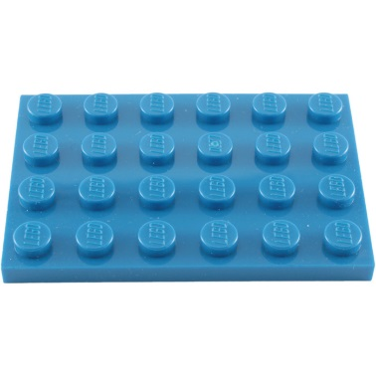  - Use many 2ps to practise counting in twos. Can you write out the two times table using the 2ps to help you? Can you work out how many 2ps make 18p?  - As above but with 5ps and 10ps.  - Share out a handful of grapes or a packet of raisins between two people. How many do they get each? Is it equal? How about sharing them between 3 or 4 people? Is that equal and fair?
Time | - Tell the time to o’ clock on an analogue clock with the batteries taken out. Then once confident with this, tell the time to half past the hour.  - Look at the digital clock time and match it to the o’ clock times with the help of an adult.  - Set the alarm to go off each half an hour and predict where the hands will be each time. Can you detect a pattern?  - Work out a basic timetable for a school day. What time do you wake up? Have breakfast? Leave for school? Come home? Have dinner? Go to bed? Draw pictures to match the times on the clock.

