Home Learning Plan
Week beginning: Monday 10th January 2022 |  |  | Year: 2
Literacy
Reading  and phonics |  | Start your day by reading a levelled book on your own for 10 minutes.  https://www.oxfordowl.co.uk/for-home/find-a-book/library-page/  https://home.oxfordowl.co.uk/reading/free-ebooks/  If you would like to do some more phonics activities, please see links below for some phonics games  https://www.phonicsbloom.com/  https://www.topmarks.co.uk/english-games/5-7-years/letters-and-sounds  https://www.phonicsplay.co.uk/  https://monsterphonics.com/free-resources/fun-ways-to-help-children-learn-phonics-spelling/
Handwriting | M | ur
 | Tu | er
 | W | or
 | Th | oor
 | F | url
Spelling | M | This week our focus is: 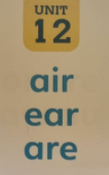  Our key words are:  air fair hair pair chair stairs bear pear tear wear care dare share scare  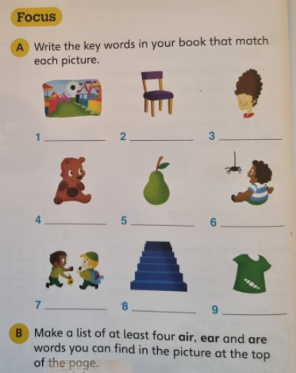
 | Tu | 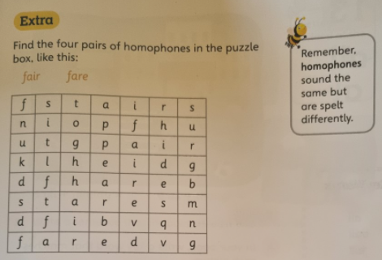
 | W | (No spelling due to PE/ICT)
 | Th | 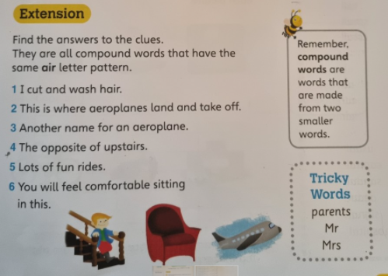
 | F | Write 5 silly sentences using as many key words as possible.
Literacy | M | I can plan my own recipe for how to make a Biscuit animal.  Re-watch the story of Biscuit Bear. Remember to do your actions!  Do you want to make a biscuit bunny? A biscuit dog? A biscuit kitten? Today you are going to plan how to make a biscuit animal of your choice. Remember, when we are planning we are going to do short notes/ key words or little pictures. Think about how you will decorate your biscuit.  Plan your recipe using the Instructions Planning Frame.
 | Tu | I can write the title, introduction and ingredients list for my recipe.  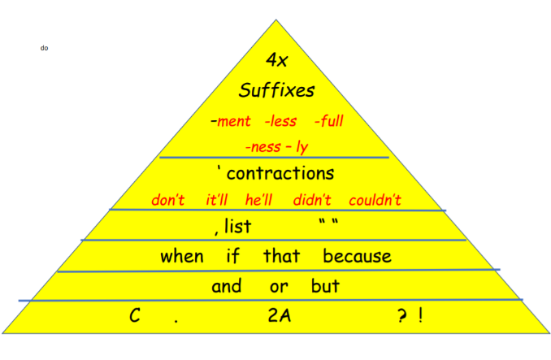  Today you are going to be writing the title, introduction and ingredients list for your recipe. Remember that when we are writing, we need to include as many things as possible from our writing triangle.
 | W | I can write the method for my recipe.  Today you are going to writing the method for your recipe that was shown in the story of Biscuit Bear. Remember to use your FANTA words (first, after that, next, then, also). Try to include as many things from your writing triangle as possible.
 | Th | I can write the concluding paragraph, top tip and draw a simple diagram for my recipe.  Today you are going to be writing the concluding paragraph, top tip and drawing a simple diagram for your recipe. When you have finished, use your purple pen to find any missing Capital letters and Full Stops.
 | F | No Literacy due to PE Slot
Maths |  | Start your maths by practising your counting with a couple of these counting songs!  Count in 2s  Count in 5s  Count in 10s  Each day click on the link below and find the video for each learning objective. Then complete the corresponding maths worksheet which can be found under the resources for each day.  https://whiterosemaths.com/homelearning/year-2/week-12-number-multiplication-division/  Extra Challenges (Optional):  If you would like to challenge yourself further, please complete the optional extension maths sheets that I have provided for each day.
 | M | I can understand multiplication sentences using the x symbol.
 | Tu | I can understand multiplication sentences from pictures.
 | W | I can use arrays.
 | Th | I can make doubles.
 | F | I can understand the 2 times table.

