Show and Tell Homework 8.10.21
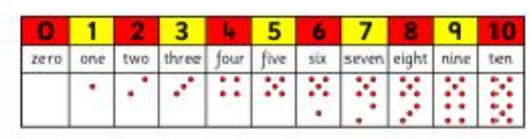

This week we would like you to practise any letters or numbers you find tricky! Do you get some numbers back to front? Do you find some numbers hard to spell? Do you muddle up some letters? Practise makes perfect! You can do this here in your book or:
- in chalk on the ground
- in paint on paper
- use water and a paintbrush on the dry walls outside
- write in sand or flour on a tray
- use colourful pens to draw over the letter or number over and over again
- write on your hand with your finger
- write on a sequin cushion or fluffy carpet or blanket
We are including the letter rhymes to help you.

