Home Learning-Afternoon Activities
Spring Term 1 2021
Subject - DT
Topic -TRANSPORT
Week | Learning Objective | Activity
1 | DESIGN  design purposeful, functional, appealing products for themselves and other users based on design criteria  generate, develop, model and communicate their ideas through talking and drawing  MAKE  select from and use a range of tools and equipment to perform practical tasks  EVALUATE  evaluate their ideas and products against design criteria  TECHNICAL KNOWLEDGE  build structures, exploring how they can be made stronger, stiffer and more stable  explore and use mechanisms [for example, levers, sliders, wheels and axles], in their products. | Design and build a bridge  Use LM powerpoint to introduce for ease of teaching and for home learning use.  Look at pictures of different bridges and discuss whether they are built for Cars, people or trains to use (or a combination!)  Discuss bridges that the children might have crossed/used eg Tamar Bridge / rope bridge at Heligan.  Challenge children to design a bridge for either a toy car to dive over or a Lego figure to walk over. Can they label it to show their choice of materials?  Children build bridge and evaluate it – can they improve it? What would they do differently?
2 - 4 |  | Design and build a moving vehicle  This activity can be done at school or at home and can take up to 3 or 4 sessions to complete.  The amount of supported and independent work will depend on the age/ability of the children.  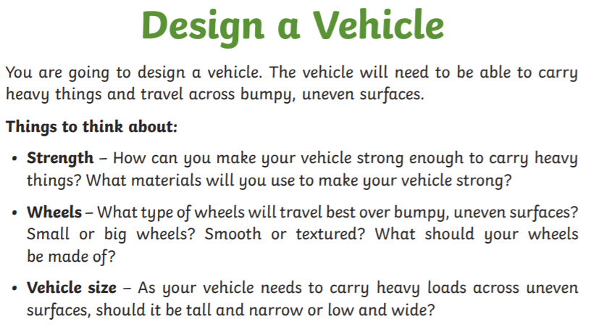  Session 1  Children to think about features of tractors and other strong vehicles which are used to carry heavy loads.  Show/tell children what resources will be available eg empty food boxes, cardboard tubes, straws, wooden dowels and wheels.  Children to decide which resources they will need and draw a labelled diagram of their vehicle.  Session 2  Watch ppt or adult to demonstrate how vehicles move through use of axles/wheels.  Gather materials and support children to build their vehicle.  Session 3  Once the vehicle is dry/set the children can evaluate how successful they have been. What do they like about their vehicle? Would they change anything? What have they enjoyed about making their vehicle?

