Homework 4th December 2020
PLEASE REMEMBER, YOUR CHILD CAN ATTEND HOMEWORK CLUB ON MONDAY LUNCHTIME IF THEY REQUIRE ANY EXTRA HELP WITH THEIR HOMEWORK.
Literacy
Please complete and practice your YouthSpeaks presentation. Try to perform it at home to an audience. Remember, your speech should last for around 3 minutes.
Grammar
Page 50 of your book this week, please, about Apostrophes. There are two main uses for apostrophes, can you make revision notes about them and complete the “Try this” on page 51.
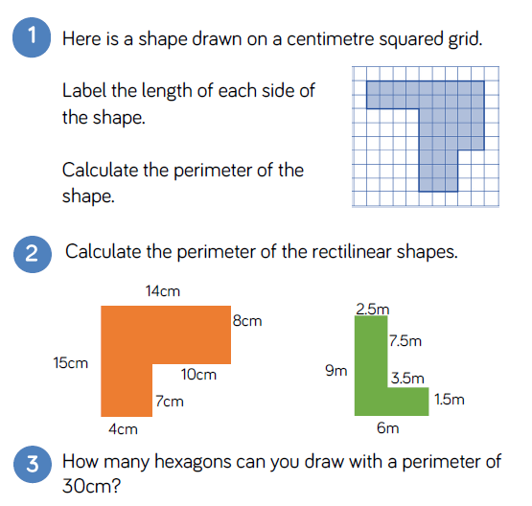
Maths

All try questions 1 and 2.
Question 3 is a challenge activity if you want to try it.

Remember, rectilinear means shapes using straight lines.

