Tell: Show 3; Examples

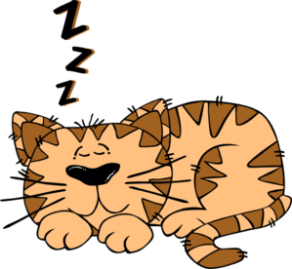He was feeling relaxed: shoes off; shirt undone; lying on the sofa.

It was a sleepy town: shops shuttered; cats lazing in the shade; dogs snoozing in the sun.

( Use a colon followed by 2 semi colons to separate)

(Proper)Noun –Adjective Pair–

Ben Roberts – weak and nervy – was actually a superhero.

Little Tim – happy and generous – was always fun to be around.

Remember the dashes

What + !

(Exclamation sentence)

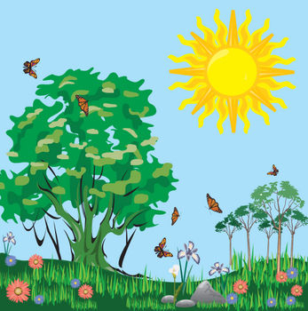What a lovely day!

What a truly ghastly sight!

What a tragic event!

What an innovative design!

(What + adjective + subject!)

Adverbial Opener :With a(n)

Remember the commas after the adverbial of ‘how’

With a smile, Greg waved goodbye.

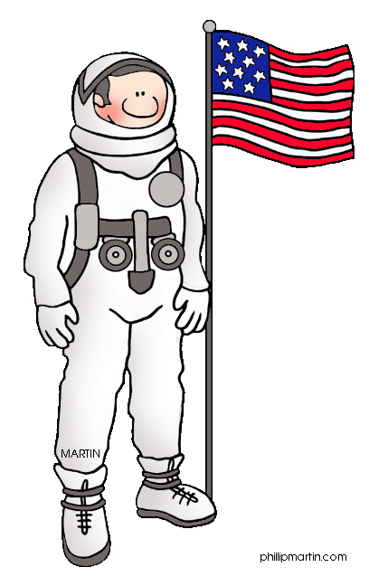

With a weary wail, Thor launched his final attack.

With a deep breath, Neil Armstrong stepped carefully onto the surface the moon.

Preposition+ Noun Phrase, Subject + Verb

At the top of the tallest tree, the monkey sat and gobbled down the banana.

High above the ruined skyscrapers, Jess could see clouds of giant insects swarming across the sky. 

**2 pairs**

[](http://www.google.co.uk/url?q=http://www.i2clipart.com/clipart-al-tired-512x512-35c0&sa=U&ei=GBKkU76QNoaqPOqAgbgG&ved=0CBoQ9QEwAg&usg=AFQjCNFOiJlXf6Qoe22yz0ac7Thc5m6Zqg)

**Exhausted and worried**, **cold and hungry**, they did not know if they could continue.

**Injured and terrified**, **confused and lost**, he wandered aimlessly across the battlefield.

(2 pairs of related **adjectives**)

**Relative clause**

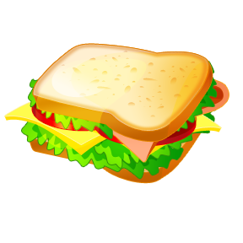**Remember the comma sandwich!**

Cakes, which taste fantastic, are not so good for your health.

Harry Potter, who was a valiant hero, battled against the malevolent Voldemort.

Remember to use commas to show where the relative clause is.

**De: de**

[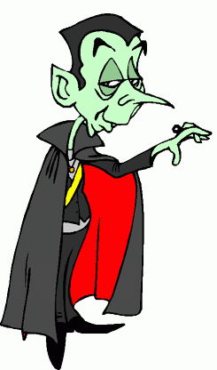](http://www.clipartbest.com/clipart-direkgg7T) **(Description: Detail)**

**Remember the colon**

The vampire is a dreadful creature: it kills by sucking the blood from its victims.

**Some; others**

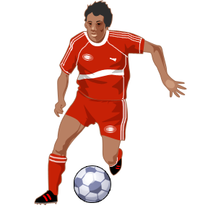

Some people love football; others have no enthusiasm for it and prefer rugby.

**Remember the semi-colon**

**Outside (inside) sentences**

[](http://www.google.co.uk/url?sa=i&rct=j&q=handshake%20clipart&source=images&cd=&cad=rja&uact=8&docid=6o05QUKSLvS-qM&tbnid=KrGp3yBIz3VtUM:&ved=0CAUQjRw&url=http://sweetclipart.com/business-handshake-81&ei=BRenU4fsEoy70wXiuYGoBg&bvm=bv.69411363,d.d2k&psig=AFQjCNG2-JpVpWKyy-V6mGynubOumlCwOw&ust=1403545727581451)

He smiled and shook the man’s hand warmly. **(Inside**, however, he was more angry than he had ever been.)

**Remember the brackets for parenthesis.**

**Sentence of three**

(3 is the magic number)

[](http://www.google.co.uk/url?sa=i&rct=j&q=magic%20clipart&source=images&cd=&cad=rja&uact=8&docid=3loltJdXdF0Z5M&tbnid=MRs6-mUbBNprIM:&ved=0CAUQjRw&url=http://www.clipartlord.com/category/miscellaneous-clip-art/magic-clip-art/&ei=Mx-nU6SONabP0AWd9YH4AQ&bvm=bv.69411363,d.d2k&psig=AFQjCNEsPjR9Y1vmd7HU1zBxcRi6DN8-yg&ust=1403547819801712)

Mrs Jones had a mean mouth, cruel eyes and red hair.

He ran down the stairs, grabbed his coat and rushed straight out the door.

Frogs live in still water, can jump on land and have powerful legs.

As_Ly

(As + adverb + comma)

As the rain came down heavily, the children ran for shelter.

As the wind screamed wildly through the blackened trees, the lost giant lumbered along the path.

**Subordinate clauses**

(Extra information for interest! Can be at the start, in the middle or the end of a sentence)

[](http://www.clipartsfree.net/svg/4749-knight-vector.html)

Sir George, exhausted by the battle, fell to his knees.

Exhausted by the battle, Sir George fell to his knees.

Sir George fell to his knees, exhausted by the battle.

**Passive Verb Opener**

MC900078715[1]MC900383564[1]MC900383592[1]

Laughing, he... Running Crying

**Passive Verb Opener**

**Simple sentence**



I like apples.

**Adjective,Adjective sentence**

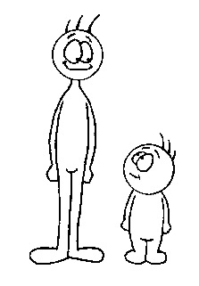

He was a tall, thin man.

(Expanded noun phrase for each noun.)

**Time conjunctions**

[](http://www.google.co.uk/url?q=http://openclipart.org/tags/alarm-clock&sa=U&ei=Z9qjU_mUM6nx0gXX-YGoBA&ved=0CDgQ9QEwEQ&usg=AFQjCNFiz68RRryHzgfQWIZK5aYm_Xm4iA)First,

Next,

Then,

In the morning,

Yesterday,

After that,

(Use a conjunction of time followed by a comma to begin your sentence.)

Finally,

**Sticky Glue words**

(Compound sentence)

[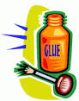](http://www.google.co.uk/url?q=http://bestclipartblog.com/22-glue-clip-art.html&sa=U&ei=zdqjU_OnKfDa0QWas4HADw&ved=0CCIQ9QEwBg&usg=AFQjCNHLYqQ-4zWcACDO3DQNumIGgBtZGQ)He was a friendly man most of the time **but** he could be nasty.

**Use a coordinating conjunction (and, but, so) to join two simple, related sentences.**

**Question sentence**

Why did he choose that path**?**

Where does a hippopotamus live**?**

**(Your sentence must end with a question mark.)**

**List sentence**

MC900295988[1]When Dad went shopping he bought some plums**,** strawberries**,** oranges **and** lemons.

**Use commas to separate the items in the list.**

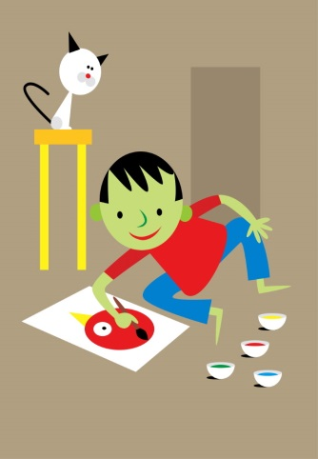**BOYS**

**(but, or, yet, so**)

He was a friendly man most of the time, **but** he could become nasty.

He could be really friendly, **or** he could be miserable.

It was a warm day, **yet** he was shivering.

It was a beautiful morning for a walk, **so** he set off quite happily.

(Use a coordinating conjunction to create a compound sentence.)

**ly sentence**

Mightily, the lion pounced on its prey.

Gracefully, the eagle soared through the fluffy clouds.

**(Begin your sentence with an adverb explaining ‘how’ followed by a comma.)**

**If, then sentences**

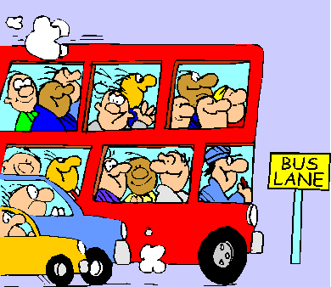**If** the bus had been on time, then he would not have been late for work.

**(Cause and effect conjunctions)**

Description, Which + Simile

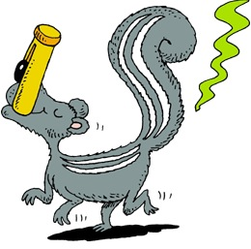Greg had huge nostrils, which made him look like a hippo.

Doctor Swogflop bathed only once a year, which meant he was as smelly as a skunk’s bottom most of the time!

Comma before the conjunction (which)

Trailing Off…

Use an ellipsis at the end to create suspense!

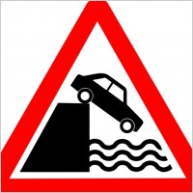He smiled, took her hand and led her away from the house…

The car sped over the ledge towards the rocks below…

**The more, the more**

**The more** upset she became, **the more** her tears flowed.

Emotion/adjective comma action related

to the emotion

[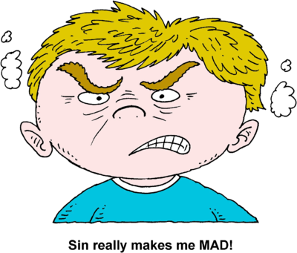](http://www.google.co.uk/url?sa=i&rct=j&q=angry%20clipart&source=images&cd=&cad=rja&uact=8&docid=huuKLYfE2FpSWM&tbnid=zV7BdMB4ZrCr4M:&ved=0CAUQjRw&url=http://www.christart.com/clipart/image/mad&ei=ShWnU5SDFMGn0AXE54CAAg&bvm=bv.69411363,d.d2k&psig=AFQjCNHEv2fEp418c9EBGed5F5DRgBBAyg&ust=1403545277496673)**The more** angry he became, **the more** he hammered his fist on the table.

Same Word End of 2

(End two consecutive sentences with the same word.)

The work was **hard.** It was depressingly, horribly, unbelievably **hard**.

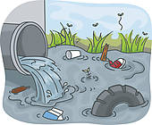Polluting our oceans is both a long and short term **mistake**. For both the flora and fauna of our oceans it is already a calamitous **mistake**.