Homework 25/11/2020
PLEASE REMEMBER, YOUR CHILD CAN ATTEND HOMEWORK CLUB ON MONDAY LUNCHTIME IF THEY REQUIRE ANY EXTRA HELP WITH THEIR HOMEWORK.
Literacy
Begin a short discussion for YouthSpeaks, maybe Lockdown ending and what rules do we feel would be appropriate to allow a safe and happy Christmas break, or the Australian bushfires.
You will be able to finish this next week.
Grammar
Revise expanded noun phrases in your orange book and write 5 sentences using different expanded noun phrases.
Maths
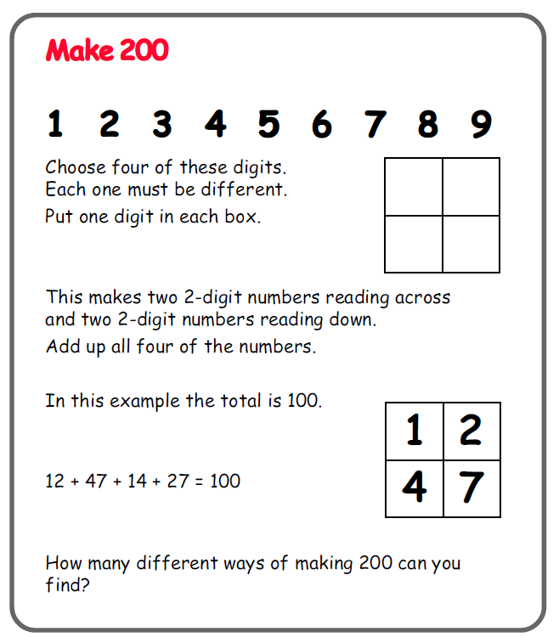
(All try the first problem then scroll down for more challenges which are optional)

