Year F Weekly overview of learning Week Beginning 8th November 2021
We hope you find the following plan helpful. We would love to see what you do – perhaps put some pictures on Tapestry for us to see.
Phonics and Handwriting
Phonics | Practise the set 1 RWI sounds you have learnt so far. Our new sounds this week are: y, th, q, x and ch. There are flashcards below the home learning plan on the website for you to use if you wish or attached to Tapestry.  Choose from a few activities below to help practise your sounds. You don’t have to do them all.  - How many things can you find in your house that start with those new letters?  - Try sorting objects that start with those letters into 3 groups labelled with some sounds.  - Write out CVC words that use letters you’ve learnt so far. For example - bin, cat, cot, can, kit, mud, up, cup, bad or the nonsense alien words tog, bon, pim and bup. Practise reading these by sounding out the words and blending them.
Handwriting | You can also practise writing some of the letters we have learnt so far. Maybe you could write them in chalk, paint them or use a wet paintbrush to write them on the patio outside. The rhymes we use when we write our letters is below the home learning plan on the website or attached to Tapestry.  You could also practise writing the red words you know so far: I, the, you and the new one this week – no.

Maths
Counting games | We are enjoying singing lots of maths songs. These are particularly valuable this week, when we are exploring numbers 1-5 They help reinforce the concept of 1 more/1 less. You can find number songs by following this link:  - Counting songs - BBC Teach
Maths
Shape
We are reinforcing the work we have done on shape so far for part of this week. We are looking at Rangoli patterns as part of our learning about Diwali. Can you make your own Rangoli pattern using blocks, colouring, painting or construction?

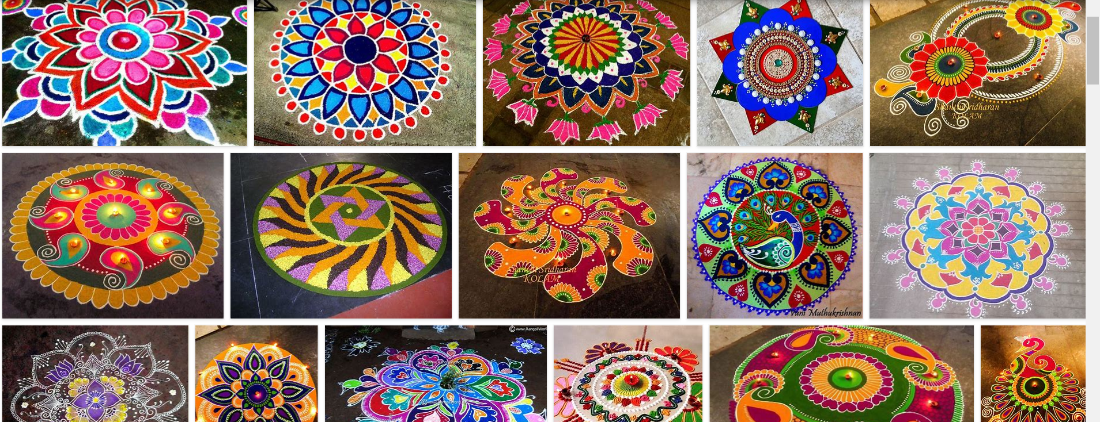

Number 4

We are learning all about the number 4 and how it can be represented in different ways. Here are some activities you could do to explore 4:
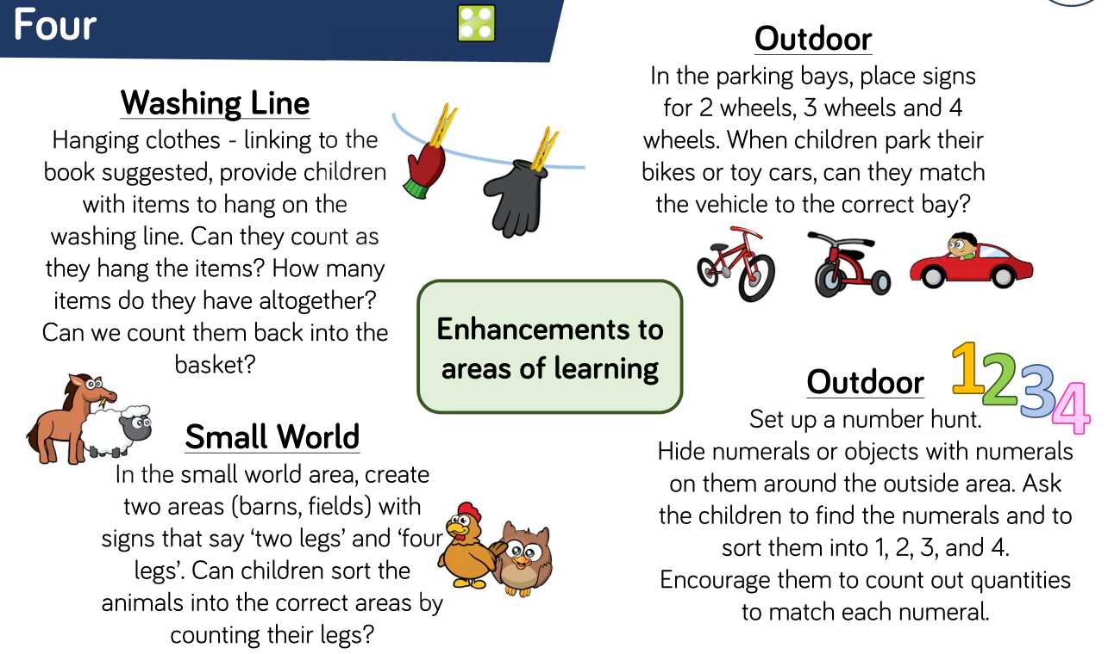

You can watch a Numberblocks episode on the number 4 by following this link:
BBC iPlayer - Numberblocks - Series 1: Four

Afternoon activities

You can choose from a selection of the activities below:
- Remembrance Day
We will be learning about Remembrance Day. You can watch a lovely short video about a rabbit going through the poppy fields shown on Cbeebies here:
Poppies - CBeebies - BBC
Perhaps you could make your own craft poppy. Here are some ideas:
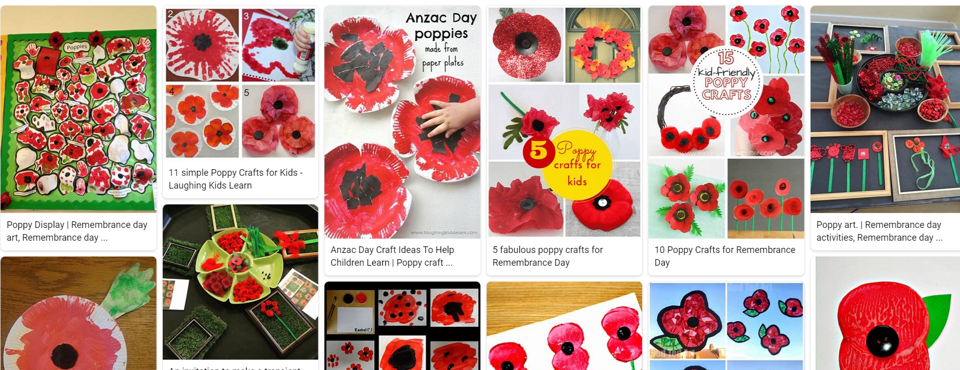

- India – can you find out where India is on Google maps. What do they eat? What clothes do they wear? What do the temples look like? Can you make a temple out of bricks?
- Try learning a simple dance to celebrate Diwali. You can find some by following this link:
DIWALI SPECIAL DANCEALONG for kids | 4 min easy dances - YouTube

