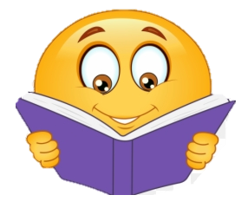
KS1 Reading
Challenge!
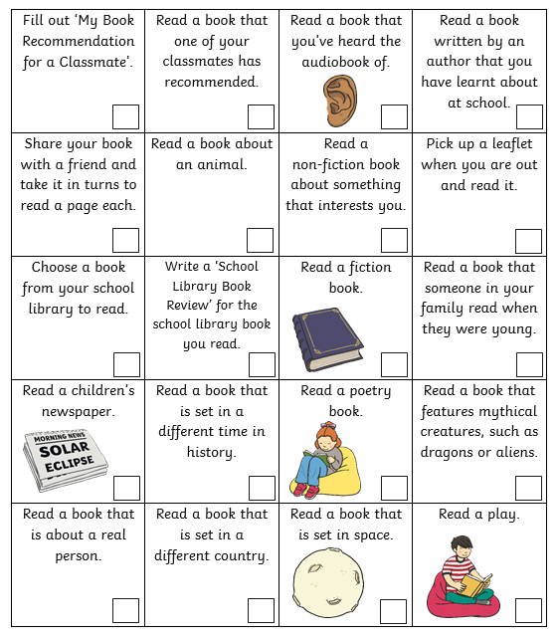
During the school year of 2021-2022 try to complete some of these reading challenges to get a Reading Challenge Certificate!
5 Challenges – Bronze
10 Challenges – Silver
15 Challenges - Gold

For each challenge, write the title of the book that you have read. Make sure that you read carefully as I may ask you about some of the amazing books that you have read!
When you have completed 5, 10 or 15 challenges, the challenge, please tell your teacher or speak to Miss Reeve!
Happy Reading!
Miss Reeve
