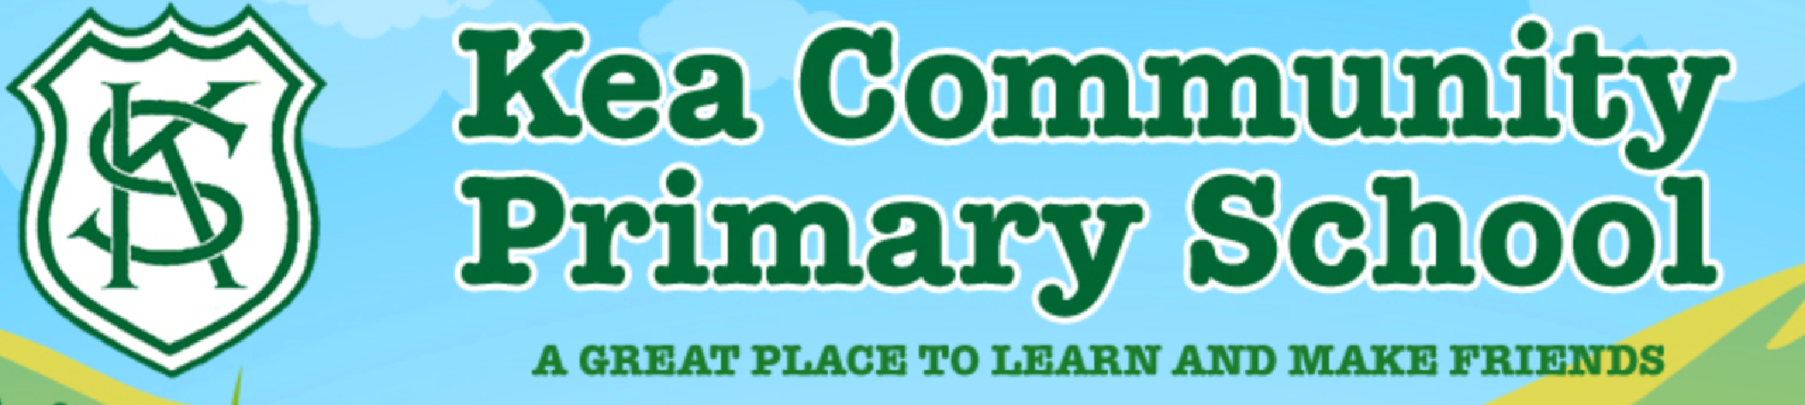
Maths and Literacy Learning Plan
Date: Week beginning 5th January 2020 | Class: Foundation
Literacy
RWI | We are revising all of our Set 1 sounds this week. In school, we will be taking 8 sounds a day from Set 1. We will use the letters each day to make up decodable words and to practise sounding out the words using our Fred Fingers. You could write these letters on cards which you could manipulate to make different words:  m a s d t, i n p  g o, c k u b, f e  l h sh, r j v y w  th z ch qu x ng nk  We will continue to concentrate on red words from the red word list at the front of the reading record.
Handwriting | This week we will practise forming some letters each day from the letter groups above.
Spelling | Specifically we will be covering the words I, got, thank, you as part of our writing tasks.
Writing tasks | - I got a…  We will be talking with the children about what presents they got for Christmas in circle time.  We will talk about and model the sentence ‘I got a…’. We will use this opportunity to talk about capital letters, finger spaces and full stops. Each child will write their own ‘I got a…’ sentence, putting in one of their favourite presents. We will encourage the children to sound out their word using their Fred fingers. The children can draw a picture of their present. Some children may wish to extend their ‘I got a…’ sentence further by writing more about their toy.  - Thank you letter  We will be talking about how it is good to say thank you for presents and will be modelling how to write a thank you letter. At this stage, we won’t be expecting the children to write a whole letter. It’s ok for them to fill in the gaps of a letter (as shown below), just writing one or two words. Some children may be able to write a whole simple letter. Every child is different. It’s just important that they learn to have a go and get their confidence.  To ……………  Thank you for my …………….  Love From ………………….  You can even send the letter in the post – a useful experience for the children.

Maths
Counting and other skills. | Roll a dice. Can they tell you the number on the dice without counting the spots? This is called subitising (knowing how many without counting). Play some board games, such as Snakes and Ladders, practising subitising. You can also practise this skill with any objects that are around the house – a really useful skill.
Learning Task | This week we are concentrating on the numbers 6 and 7.  Six and Seven  Task 1  Begin with reading the story Six Dinner Sid. The link to a video is here:  https://www.youtube.com/watch?v=3XAdTJCtgTs  How many times do they meet 6 ? Ask the children to make houses to represent Sid’s street. Can they number the doors and order the houses from 1 to 6? What if we added another house? And another? Use the opportunity to talk about 1 more. Use a numberline to help see the next numbers. The children could make the street out of blocks or construction materials.  Task 2  How many legs does a ladybird have? How many spots? Do you know any other creatures with 6 legs? Use counters to add 6 spots to the other ladybirds. Can you find more than one way to do it?  Task 3  Look at some pictures of rainbows.  How many colours do you see in a rainbow? Can you paint a rainbow with 7 colours? Can you make rainbows using objects around the room? Perhaps you could make a giant rainbow using found objects? How many colours did you use?  Task 4  To reinforce the numbers 6 and 7, watch these two Numberblock videos.  6: https://www.bbc.co.uk/iplayer/episode/b08pgksd/numberblocks-series-2-six  7:  https://www.bbc.co.uk/iplayer/episode/b08pgqt4/numberblocks-series-2-seven  Task 5  Use any opportunity this week to refer to 6 and 7 – can they spot the numbers around them. Can they count out accurately?

Other Subject:
Topic | Our new topic for this half term is transport. KS1 and Foundation are focussing on this.  Talk about some journeys you’ve been on and what transport you’ve used. You could look at some family photos. Use some construction toys to build some different types of transport. How to they move? Where are you going? What will you do when you get there?

