Our story starts …..  1. | 2. | But today ….  3. | 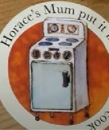  4.
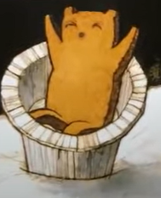  8. | 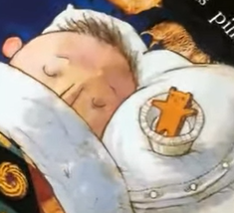  7. | An hour later …..  Before bedtime ….  6. | Twenty minutes later ….  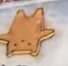  5.
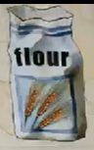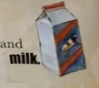  9. | 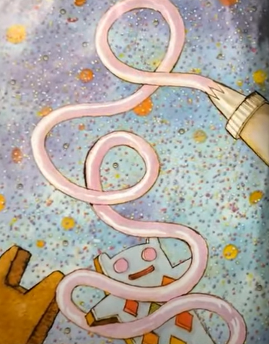  10. | 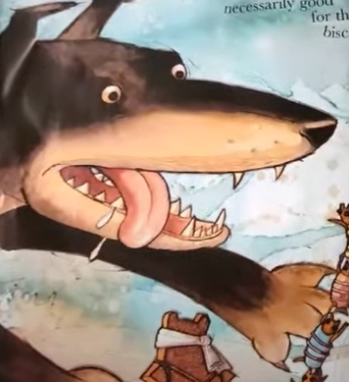  11. | 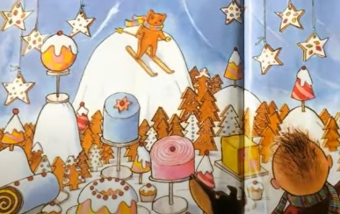  12.
1.Our story starts with a lump of pastry that Horace’s mum gave him.
2. He would roll it over the floor and furniture until it was grey and fluffy.
3. But today Horace’s mum gave him a biscuit cutter in the shape of a bear. Horace stamped out a pastry bear and gave him a currant eyes and nose.
4. Horace’s mum put it in the oven to cook.
5. Twenty Minutes later the biscuit bear was golden coloured and smelt lovely. Horace wanted to take a bite BUT no Horace! It’s too hot! You must wait for it to cool down!
6. An hour later Horace remembered the biscuit but his mum said.. No Horace! You will spoil your tea. Before bedtime Horace wanted to take a bite but mum said “No, you have cleaned your teeth”
7. Horace put the biscuit bear in a little tin and put it on his pillow.
8. It was the middle of the night and Biscuit Bear woke up alone. “I shall make some friends” he said to himself.
9. Biscuit Bear found butter and flour and milk. He mixed up a mixture and rolled it and shaped it in to friends and put in the oven to cook.
10. When they had cooked, Biscuit bear dressed the bears in icing, hundreds and thousands, cherries and little silver balls.
11. Bongo the dog liked biscuits, but not in a good way! Biscuit Bear managed to just climb to safety. He realised that he needed to find a safe place to play.
12. The life of a biscuit is short and sweet but biscuit bear finally found a place to be safe. Biscuit bear is in the Pastry Shop display! Some of it is cardboard covered in Icing, some of it is plaster, but it can never be eaten. Biscuit Bear was always the Star in Spring, Summer, Autumn and Winter.

