Maths and Literacy Learning Plan
Date: 11th January 2021 | Class: Foundation
Dear Parents and Carers,
We understand that these are challenging times. We have prepared these plans for your children for reading, literacy and maths to support you while the children are at home. BUT we recognise that your children are 4 or 5 years old and that they also need lots of time to play. In school, our days are not this structured, the children are not expected to do phonics, followed by literacy, followed by maths, followed by an afternoon activity. They are given time away from formal learning, to follow their interests and learn through continuous provision. A lot of learning at this age takes place through playing: learning about taking turns, being kind, not always winning – these things are vital for children of any age, but especially in Foundation. So, please don’t be overwhelmed – choose the activities which work for you and your family - do what you can. As a guide, we would suggest doing at least some phonics, reading and maths every day if possible.
Catherine and Lisa
Literacy
Reading | Please make sure you have read the ‘YF Reading and Phonics Information Document January 2021’ sent out on Friday. This is in the literacy general resources section of the YF website, but has also been sent to you on Tapestry (where we have also stated which set of sounds your child should focus on).  RWI  Watch the daily RWI phonics videos for today. You should choose either set 1 or set 2 videos to watch. These will practise your speed sounds, spelling, writing and reading over the course of the week.  To find these videos please follow this link:  https://www.youtube.com/channel/UCo7fbLgY2oA_cFCIg9GdxtQ?mc_cid=71ef745098&mc_eid=c9705b8c67  Reading  Read your reading book daily, either borrowed from the box in reception at school or online. Also practise some of your red words.
Handwriting | Handwriting will be covered in some of the daily RWI phonics videos above. However, below you will find some more handwriting ideas should you wish to practise more.  Letter formation is an integral part of developing a child's fine motor skills. It is useful to teach children how to form their letters in stages using handwriting families which will improve presentation.  This week we will be looking at curly caterpillar letters.  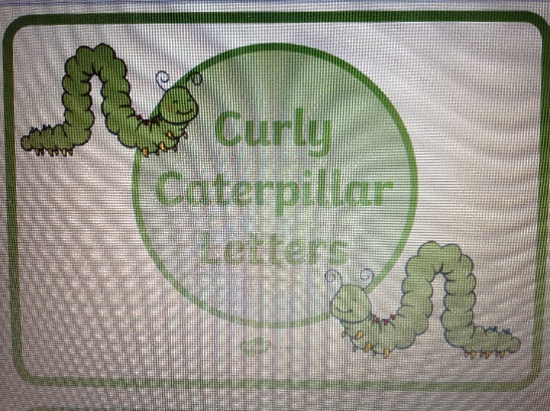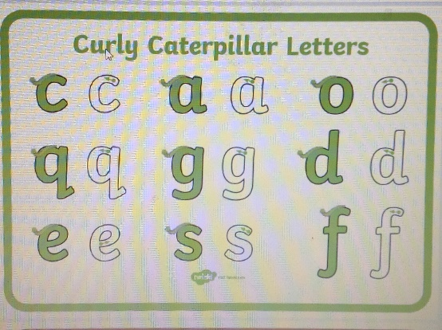  If you practise these, try to make your letters the same size. Remember to use the Read Write Inc rhymes for each letter. The rhymes can be found on the general resources section of the website.  You may like to watch this little video on curly caterpillar letters:  https://www.bbc.co.uk/bitesize/topics/zgjj6sg/articles/zwnh4qt  You don’t have to write them on paper all the time in pencil. A wet paintbrush outside on the patio, using chalk or paints, writing using your finger in icing sugar…anything is valuable practise. Even use different coloured pencil crayons or pens.
Literacy tasks | 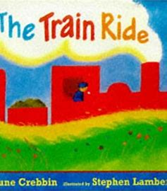  Monday  Talk about train rides. Have you ever been on a tra n Where did you go? Read the story ‘The Train Ride’.  Watch the video ‘The Train Ride Literacy Lesson Tuesday’ on the home learning page, a video by Mrs Harvey.  You can also find a recorded version by following this link on Youtube:  https://www.youtube.com/watch?v=RoEvHK_mP4Y  Re-read/listen. Can we predict (guess) what is coming next? Talk about how words are repeated. Act out the story using actions that you make up.  Tuesday  Watch the ‘Train Ride Literacy Lesson Tuesday’ by Mrs Harvey  In this video, you will be re-reading and listening to the story ‘The Train Ride’. Can you remember the repeating words? Encourage the children to join in.  If your train went on a journey, where would it go and what would it pass along the way? Use a wooden brio train set to build a train journey. If you don’t have a train set, perhaps you could draw some train tracks instead. Use toys to add to the journey. Cut some strips of paper to write what the train passes along the way (labels). Use your Fred Fingers to help you sound out the words.  Wednesday  Have a look around the kitchen with your parent or carer. Help them to write a simple shopping list for what you need the next time you go shopping.  Thursday  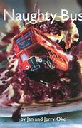  The Naughty Bus by Jan and Jerry Oke  Watch ‘The Naughty Bus Literacy Lesson Thursday’ video on the home learning page.  In this video you will be talking about bus journeys. Have you ever been on a bus? Share with the children some photographs of London buses and other types – compare and discuss (see word document). How is the London bus different to buses that the children may have seen? Has anyone been to London and had a ride on a London Bus?  Talk about the journey the bus went on. Was the bus on an adventure? Who took the bus on its adventure? Was the bus really ‘naughty’? Can they think of a better word to describe the bus?  Choose a vehicle. You could pick a favourite, or build one of your own out of construction materials or junk. It could be a car, van, monster truck, train, canoe – it’s your choice. What adventure would your vehicle go on? Using items around the home or classroom, build a journey for your vehicle. Take some photos or videos of your journey to use tomorrow.  Friday  Watch the ‘Naughty Bus Literacy Lesson Friday’ video on the home learning page.  The children can have a go at drawing a map of where their vehicle went on their journey. It may be a bus, car, boat, aeroplane – the choice is theirs. They could add some labels if they wish. You could use photos of yesterday’s journey to remind them or make up a new adventure.

Maths
Counting and other skills. | Here are a few counting and number activities:  - Practise counting forwards and backwards to 10. Can you shout the numbers, whisper the numbers, say them in a funny voice? You could extend to numbers to 20.  - Try shouting and whispering the numbers alternately: 1, 2, 3, 4, 5 etc. Do this going up and down. Can you do it with numbers to 20?  - Play ‘Last Man Standing’ Count backwards around a circle of people: 10, 9, 8, 7, 6, 5, 4, 3, 2, 1, 0. The person who says 0 sits down and the counting continues, starting again from 10. Who will be left standing? You could play this with toys such as superhero toys, transformers, teddies or dolls, taking one away each time.
Learning Task | Consolidating 6, 7 and 8  This week, we will be continuing to understand the numbers 6 and 7, adding 8 to the list. There will be lots of opportunity to manipulate materials and see these numbers in different representations. There are activities listed below for each day. You do not have to do them all – just do what you can. Also, many of these tasks can be adapted to being done outside in the garden or when out on your walk.  Monday  Watch the Numberblocks video all about the number ‘8’.  https://www.bbc.co.uk/iplayer/episode/b08pgvmb/numberblocks-series-2-eight  Watch Mrs Marley’s video about using a ten frame, then you are ready to have a go at today’s activities.  Write the numbers 1-8 onto cards. Turn them over face down. Turn over a card and use some objects to fill the 10 frame up with that number of items.  Please remember that the children may put the items in seemingly random places on the 10 frame. This is fine and valid to them. Ultimately, we are wanting to move the children to filling up the first line, before moving onto the second, such as the drawing below:  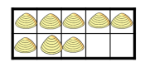  Tuesday  Watch Mrs Marley’s minibeast video.  - Go on a mini-beast hunt. Look closely at the creatures you see. How many legs can they see? What creatures have you found. Make a careful drawing of the creatures you find.  - If the weather is not good or you are unable to go for a walk, the children could design some minibeasts of their own using craft materials.  How many legs does your minibeast have? Can you write a label to show. Does it have a name – could you write that?  Wednesday  Encourage the children to think about where we see 6, 7, and 8 in everyday life and to make collections of 6, 7 and 8 objects from home. How else could you show 6, 7, and 8? You could have a tea party with different plates numbered with 6, 7 and 8 or create a farmyard out of construction blocks and toy animals, numbering the fields with different amounts of animals. It could be food on your plate at dinner.  Thursday  Link this with the story read in Literacy today, ‘The Naughty Bus’. Arrange chairs to be set out like a bus (with 8 seats in pairs). At home, you could use something else if you don’t have enough chairs (such as cushions). Get digit cards numbered from 1-8 and turn them over so you can’t see them. Turn one over and read the number. Can you sit the teddies on the bus? What happens if 1 person gets off or another one gets on. How many do you have on the bus now? Use the language of more, less, 1 more, 1 less, take away and add as you talk about what is going on.  Friday  Read the story ‘Kipper’s Toybox’. Mrs Marley has recorded a video for you about this story:  There is also another link below to the story on YouTube:  https://www.youtube.com/watch?v=GBUW9hHpfuc  Provide a basket of toys for the children or they could choose some of their own if they wish. Take turns to ‘hide’ one of the toys. Can the children spot which toy is missing? How many toys are there now? What is an extra toy arrives? How many will there be now? Use a 1-10 numberline to help work out 1 more and 1 less. It is good practise to use a numberline to add and take away.

