Home Learning-Afternoon Activities
Spring Term 1 2021
Subject - PSHE
Please note: these plans are for YF, Y1 and Y2. Therefore, some activities can be adapted for younger or older children. It may be that older children are able to extend activities by doing more writing. Please adapt these as you wish.
Week | Learning Objective | Activity
11th January | I understand what people and things make me happy.  I understand what makes other people happy. | You may like to watch the recorded lesson video by Mrs Harvey, called ‘PSHE 11th January video lesson: Harry the Happy Mouse’.  Think of all the things that make you happy. Think of all the people who make you happy. What do you do that makes other people happy?  Tasks:  - Draw pictures of all the things that make you happy. You may wish to label some.  - Look at some family photos. Talk about what had made you all happy.  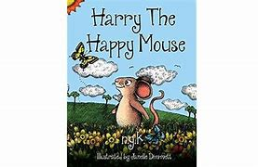  To summarise, you may wish to listen to this story again, ‘Harry The Happy Mouse’. The YouTube listen to this story:  https://www.youtube.com/watch?v=v7OsfHyqE_M
18th January | I know what I could do to fill someone’s happy bucket. | What has made you feel happy this week? What have you done to make someone else feel happy?  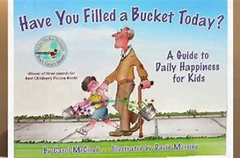  Listen to the recorded video the story ‘Have You Filled A Bucket Today?’ by following this link:  https://www.youtube.com/watch?v=3EuemNAo6XE  What do you think you could do to fill someone else’s bucket today?  Task:  During this week, and moving forward help the children to imagine whose bucket they could fill and what they could say or do to fill a bucket. Tell each other whose bucket you filled that day. Practise becoming daily bucket fillers. Very quickly they will experience the pride and joy of filling buckets. Take the opportunity to fill the children’s buckets, telling them why they are special to you.
25th January |  | 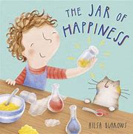  Listen to the story ‘Little Jar of Happiness’ being read on Youtube. Follow this link: https://www.youtube.com/watch?v=ilb5-PetjcE  Can you remember the colour and smell of Meg’s jar of happiness? Who did she take her jar of happiness to? Why do you think Meg couldn’t find her jar of happiness one day? What did people do to make Meg happy again? Remember that smiles, hugs, tickles, and thinking happy thoughts can help you to feel happy.  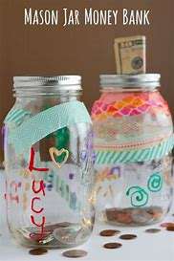  Task:  Find an old jar or container. Decorate it so it is your special happiness jar. You may like to write a label. You can then put this jar somewhere special to remind you of all the things that make you happy and what you do to make other people happy. You may wish to write things onto a piece of paper and put them in your jar. I wonder if you could do this for a period of time. At the end, enjoy opening your jar and reading all the things that have made you happy.
1st February | I understand what keeping healthy means and different ways to keep healthy. | What does it mean to be healthy? Can you think of different ways that we keep healthy? Look at the PowerPoint about keeping healthy. Take the opportunity to link this to the KS1 topic on transport, highlighting walking, running, cycling and scooting to name but a few activities we do to keep healthy.  Task  Look at the Jo Wicks powerpoint ‘Why we need to exercise’. Discuss this. Chose from some of the exercise activities below or enjoy some outdoor exercise of your own choice:  - Complete a Jo Wicks 5 minute move workout: 5 Minute Move | Kids Workout 3 | The Body Coach TV - YouTube  - Dance some GoNoodle. Mrs Harvey’s favourites are  - Dinosaur Stomp: https://www.youtube.com/watch?v=Imhi98dHa5w  - Popping bubbles:  https://www.youtube.com/watch?v=JdBlXPWM8AI  - Banana, Banana, Meatball:  Banana Banana Meatball - Blazer Fresh | GoNoodle - YouTube
8th February | I understand why sleep is important and different ways to rest and relax. | What do you do to rest and relax after a busy day? Gather lots of ideas. Why do we need to rest and sleep? Talk about the following points.  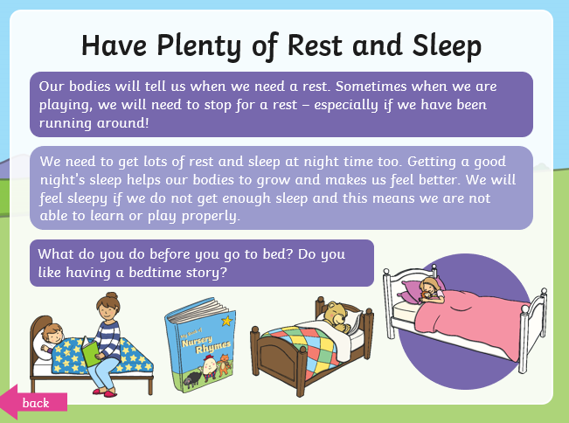  Task:  Act out with toys, getting ready for bed and sleep. Will they have a warm drink? What do they need to do to get ready for bed (teeth, wash, getting changed)? Perhaps you can read them a bedtime story?  Extra activity:  Enjoy completing some ‘Cosmic Yoga’ sessions over the next few weeks. The children love doing these in school. You can find them by following this link to the website: https://cosmickids.com/

