Tuesday 3 November

Year 1 Autumn 2

Dear Parents and Carers,

Welcome back to Year 1. We hope you had a wonderful half term and some well-deserved family time. Your wonderful children worked tremendously hard last term and adjusted to life in their new class very well. This half term, our topic is “Winter Festivals” so we will be learning about some celebratory and magical events!

In Humanities, we will be learning about the story of Guy Fawkes, why we mark Remembrance Sunday, other celebrations (birthdays, weddings, anniversaries) what Jewish people believe, the Jewish festival of Hanukah, the Nativity story and we hope to be able to visit Kea Church either virtually or in person.

In Literacy we will read and study firework poetry and write some descriptive poems of our own. We will read the book “The Jolly Postman” and discover the purpose and format of greetings cards and letters. We will write letters to another class and to Father Christmas. We will listen to and re-tell the Nativity story, re-writing part of it in our own words.

Maths learning will focus on addition and subtraction to 10, learning parts and wholes of a number, how to find a missing number in an addition or subtraction sentence, the number fact families, number bonds to 10 and finding the difference between two numbers. Please see our Maths Parent Overview for lots of guidance and fun activities to do at home.

Our Science topic will be a study of materials and their properties. We will be sorting, classifying and describing the uses of different materials, discussing where they come from and whether they are renewable.

Outdoor Days

Year 1 will be taking their learning outside on Thursday 4 and Thursday 11 November. Please send your child to school in joggers, leggings or old trousers. They can wear normal school jumpers or cardigans. Wellington boots or old shoes would be preferable and hats, scarves and warm coats are essential.

PE

PE days are Tuesdays and Fridays. Please remember to send your child to school in a warm PE kit on these days (red hoodies, green cardigans, fleeces or jumpers and dark coloured leggings and joggers).

What your child needs in school

- A named water bottle
- A named coat
- Wellington boots (optional to keep in school)
- Fruit will be provided for a morning snack or you can bring your own healthy snack (a piece of cheese, plain biscuit or your own fruit)
Please DO NOT bring in toys, games or stationary from home.

Yours sincerely,

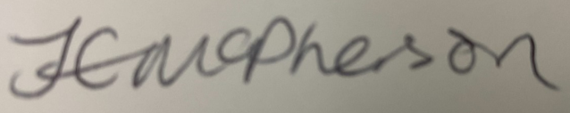

The Year 1 Team

